End-Term Project Report on
AI/ML Based Patient Health Monitoring and Alerting Robot Using Raspberry Pi

Submitted by
Satya Swarup Nayak (2341014076) (Group Leader)
Satyajit Panda (2341016091)
Shashwat Mahapatra (2341013022)
Ashutosh Upadhyaya (2341021004)
Arpan Senapati (2341019375)
Shruti Sahoo (2341019153)

B. Tech. (CSE(IOT) 5th Semester (Section–23412O3)



DEPARTMENT OF COMPUTER SCIENCE AND ENGINEERING
Institute of Technical Education and Research

SIKSHA ‘O’ ANUSANDHAN
DEEMED TO BE UNIVERSITY

Bhubaneswar, Odisha, India.
(December 2025)

Abstract
Advancements in embedded systems, Internet of Things (IoT), and Artificial Intelligence have enabled the development of intelligent healthcare monitoring solutions that are portable, affordable, and reliable. Continuous monitoring of vital physiological parameters such as heart rate, blood oxygen saturation (SpO₂), body temperature, and electrocardiogram (ECG) signals plays a crucial role in early detection of health abnormalities and timely medical intervention.
This project presents the design and implementation of an AI/ML based Patient Health Monitoring and Alerting Robot using Raspberry Pi. The system integrates multiple biomedical sensors including the MAX30102 pulse oximeter for heart rate and SpO₂ measurement, the MLX90614 infrared temperature sensor for non-contact body temperature monitoring, and an ECG sensor interfaced through an ADC for cardiac signal acquisition. A Raspberry Pi acts as the central processing unit, enabling real-time data acquisition, signal processing, visualization, and decision making.
Collected physiological data is logged into structured datasets and used to train a machine learning model capable of analyzing health patterns and identifying abnormal conditions. Based on the predicted health status, the system generates alerts using visual indicators and audible alarms. Dual OLED displays are used to present real-time vitals, ECG waveforms, system status, and risk levels.
The proposed system operates in headless mode, ensuring continuous long-term monitoring without human intervention. The project demonstrates that low-cost embedded platforms combined with machine learning techniques can provide effective patient monitoring solutions suitable for home care, remote healthcare, and emergency response scenarios.

Contents
Abstract ……………………………………………………………………………………….. i
Contents ……………………………………………………………………………………… ii
- Chapter 01: Introduction …………………………………………………………….. 1
1.1 Introduction ………………………………….................................................................... 1
1.2 Background ……………………………….................................................................... 1
1.3 Project Objectives ………………………………….......................................................... 2
1.4 Scope …………………………………............................................................................. 2
1.5 Project Management ……………………………............................................................ 3
1.6 Overview and Benefits ……………………………....................................................... 4
1.7 Organization of the Report ……………………………….................................................. 5

- Chapter 02: Background Review & Survey ………………………............................ 6
2.1 Introduction ,,,,,,,,,,,,,,,,,,,,,,,,,,,,,,,,,,,,,,,,,,,,,,,,,,,,,,.................................................................. 6
2.2 IoT-Based Healthcare Monitoring Systems ……………………….................................. 6
2.3 Heart Rate Monitoring Systems …………………………............................................. 7
2.4 SpO₂ Monitoring Systems ………………………….................................................. 8
2.5 ECG Monitoring Systems …………………………..................................................... 9
2.6 Body Temperature Monitoring Systems ………………………........................................ 10
2.7 Machine Learning in Healthcare …………………………........................................... 10
2.8 Research Gaps ………………………………….............................................................. 11

- Chapter 03: Theoretical Aspects …………………………….................................... 12
3.1 Introduction …………………………………................................................................ 12
3.2 Biomedical Sensors and Measurement Principles …………………........................... 12
3.2.1 Photoplethysmography (PPG) Theory ………………………........................................ 12
3.2.2 Heart Rate Measurement Theory …………………………........................................... 13
3.2.3 SpO₂ Measurement Theory …………………………............................................... 14
3.2.4 MAX30102 Sensor Theory ………………………................................................. 14
3.2.5 Electrocardiography (ECG) Theory ……………………........................................ 15
3.2.6 ECG Signal Acquisition Using AD8232 and MCP3008 ………....................... 16
3.2.7 Body Temperature Measurement Theory …………………….................................... 16
3.3 Project Layout ……………………………….............................................................. 17
3.4 Internet of Things (IoT) Theory ………………………......................................... 17
3.5 Communication Protocols Used …………………………........................................... 18
3.6 Raspberry Pi as an Embedded AI Platform …………………….................................. 18
3.7 Digital Signal Processing Concepts ………………………........................................ 19
3.8 Machine Learning Theory …………………………….................................................. 20
3.9 Feature Extraction Theory ………………………………................................................ 20
3.10 Health Risk Prediction Theory ……………………………........................................... 21

- Chapter 04: Hardware Requirements ……………………….................................. 22
4.1 Introduction ……………………………………............................................................... 22
4.2 Hardware Design Objectives……………………………................................................. 22
4.3 Overall Hardware Architecture ……………………………........................................... 23
4.4 Processing Unit: Raspberry Pi 4 ……………………………......................................... 23
4.5 Biomedical Sensor Subsystem ……………………………............................................. 24
4.5.1 MAX30102 Sensor ………………………………........................................................ 24
4.5.2 MLX90614 Temperature Sensor …………………………............................................ 25
4.5.3 AD8232 ECG Sensor ……………………………...................................................... 25
4.5.4 MCP3008 ADC ………………………………….......................................................... 26
4.6 Display Subsystem …………………………………........................................................ 26
4.6.1 0.96-inch OLED Display ……………………………................................................. 26
4.6.2 1.3-inch OLED Display ………………………………................................................ 27
4.7 Alert and Indication System ……………………………….............................................. 27
4.8 Power Supply Design ……………………………..................................................... 27
74.9 Reliability and Safety Considerations ………………….............................................. 27
4.10 Hardware Limitations ………………………………..................................................... 28
4.11 Block Diagram of the System ……………………………............................................. 28
4.12 Circuit Diagram…………………………………........................................................... 29
4.13 Pin Configuration……………………………………………………………………29-31
4.14 Working ……………………………………................................................................. 31
4.15 Components Required ………………………………..................................................... 32

- Chapter 05: Software Requirements………………………….................................. 33
5.1 Programming Tools and Environment …………………………...................................... 33
5.1.1 Python …………………………………….................................................................... 33
5.1.2 Thonny IDE ………………………………….............................................................. 33
5.1.3 Visual Studio Code ……………………………….................................................... 34
5.1.4 Required Software Libraries ……………………………............................................ 34
5.2 Logic and Flowchart …………………………………..................................................... 35
5.2.1 Overall Software Logic ………………………………................................................. 35
5.2.2 Step-by-Step Software Flow ………………………….............................................. 36
5.2.3 Flowchart Description ………………………………................................................ 37
5.2.4 Software Design Characteristics ……………………………...................................... 38
5.2.5 Significance of Software Design…………………………….. ...................................... 38
5.3 Machine Learning Model Training ……………………………........................................ 38
5.3.1 Objective of ML Training …………………………….............................................. 38
5.3.2 Dataset Collection ………………………………….................................................... 39
5.3.3 Data Preprocessing ………………………………..................................................... 39
5.3.4 Machine Learning Algorithm Used …………………………...................................... 40
5.3.5 Model Training Process ………………………………................................................ 40
5.3.6 Model Output…………………………………… ......................................................... 40
5.4 Mobile Application Development ……………………………........................................ 41
5.4.1 Purpose of Mobile Application ……………………………....................................... 41
5.4.2 Development Platform …………………………….................................................. 41
5.4.3 Application Features ……………………………................................................... 41
5.4.4 Data Flow Architecture ……………………………................................................ 42
5.4.5 Advantages of App-Based Monitoring ………………………….................................. 42
5.4.6 Security and Reliability …………………………………............................................. 42

- Chapter 06: Project Development & Testing Aspects……………………............... 43
6.1 Hardware Integration ………………………………...................................................... 43
6.2 Software Set-up …………………………………........................................................44-46
6.3 Testing ………………………………………................................................................... 47
6.4 Results and Discussions …………………………………............................................48-50

- Chapter 07: Conclusion & Future Scope…………………………........................... 51
7.1 Conclusion ……………………………….…............................................................... 51
7.2 Limitations ……………………………………................................................................ 52
7.3 Further Enhancement and Future Scope …………………………................................... 53
7.4 Final Remarks ……………………………………………………………………………53

References……………………………………..................................................................54-57

- Appendix 01 ................................................................................................................. 58
A01.1 Code Listing ………………………………...........................................................58-60
A01.2 Main Code …………………………………............................................................61-67
A01.3 AI/ML Model Code …………………………….......................................................68
A01.4 Libraries ……………………………………...........................................................68-71
A01.5 App Code…………………………………. ............................................................71-77

- Appendix 02 ............................................................................................................... 78
A02.1 Project Proposal Form ……………………………..................................................78-82
A02.2 Project Management ……………………………….....................................................83
A02.3 Bill of Material ………………………………….....................................................84-85

- Appendix 03 ……………………………….............................................................. 86
A03.1 Data Sheets………………………………….......................................................... 86-90

Chapter 01: Introduction

Introduction
Healthcare systems worldwide are undergoing rapid transformation due to the increasing demand for continuous patient monitoring and early diagnosis of medical conditions. Traditional healthcare monitoring methods often require patients to be physically present in hospitals or clinics, which can be inconvenient, expensive, and inefficient, especially for long-term observation. This limitation has driven the need for intelligent, automated, and remote health monitoring systems.
Recent advancements in embedded systems, sensor technology, and artificial intelligence have enabled the development of compact health monitoring devices capable of continuously tracking vital physiological parameters. These systems reduce dependency on hospital infrastructure and allow patients to be monitored in home environments or remote locations. By combining IoT-enabled hardware with machine learning algorithms, health monitoring systems can not only collect data but also analyse trends and detect anomalies in real time.
The AI/ML based Patient Health Monitoring and Alerting Robot using Raspberry Pi aims to address these challenges by providing a reliable, real-time health assessment platform. The system continuously measures key parameters such as heart rate, blood oxygen saturation (SpO₂), body temperature, and ECG signals, processes the data locally, and applies machine learning models to evaluate the patient’s health condition.
In addition to monitoring, the system includes an alerting mechanism that notifies users when abnormal health conditions are detected. Visual indicators, audible alerts, and display-based notifications ensure immediate awareness, enabling timely medical attention. The use of a Raspberry Pi allows flexible software development, multi-sensor integration, and headless operation, making the system suitable for continuous long-term deployment.

Background
Traditional patient monitoring systems are typically confined to hospitals and require specialized medical equipment operated by trained professionals. Although these systems are highly accurate, they are not suitable for continuous monitoring in home-based or mobile environments. In recent years, wearable and portable health monitoring devices have gained popularity; however, many such devices are limited to monitoring a single parameter and lack intelligent analysis capabilities. Additionally, most low-cost systems do not provide ECG monitoring or predictive health assessment. The Raspberry Pi platform, combined with biomedical sensors and machine learning algorithms, offers a powerful and flexible solution for developing intelligent healthcare systems. By integrating sensors such as MAX30102 for heart rate and SpO₂, MLX90614 for temperature, and ECG sensors for cardiac signal acquisition, it is possible to design a comprehensive patient monitoring solution. The incorporation of AI/ML allows the system not only to collect data but also to analyse trends, detect anomalies, and predict potential health risks, thereby improving patient safety and response time.

Project Objectives
The primary objective of this project is to design and implement an AI/ML-based patient health monitoring and alerting system using Raspberry Pi.
The specific objectives include:
- To design a real-time health monitoring system using biomedical sensors.
- To measure and display vital parameters such as:
  - Heart rate (BPM)
  - Blood oxygen saturation (SpO₂)
  - Body temperature
  - ECG waveform
- To acquire, process, and store physiological data in structured datasets.
- To train a machine learning model using collected health data for risk prediction.
- To generate alerts using visual and audible indicators when abnormal conditions are detected.
- To ensure stable, headless, and long-term operation of the system.

Scope
The scope of this project includes the design, development, and implementation of a standalone health monitoring robot capable of continuous patient monitoring.
The system covers:
- Hardware integration of multiple biomedical sensors
- Real-time data acquisition and visualization
- ECG waveform generation and analysis
- Dataset creation for machine learning training
- Health risk prediction using trained ML models
- Alerting mechanisms using LEDs and buzzer
- Dual-display system for data and status visualization
This project is intended for academic and research purposes. While it demonstrates intelligent health monitoring, it is not a replacement for certified medical diagnostic equipment.

Project Management
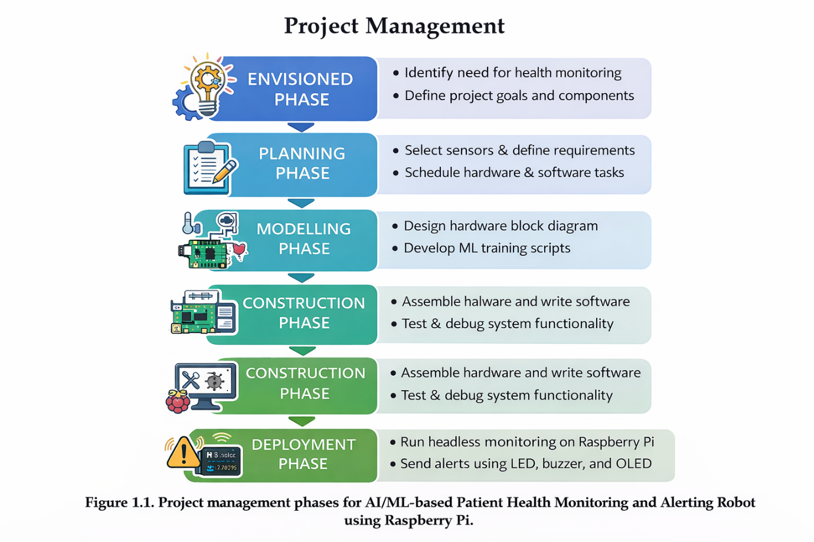

Overview and Benefits

Organization of the Report

Figure 1.1. Project management phases for AI/ML Based Patient Health Monitoring and Alerting Robot Using Raspberry Pi.
1.6 Overview and Benefits
The proposed AI/ML-based health monitoring system offers several advantages over traditional systems:
Key Benefits
- Continuous real-time monitoring of multiple vital parameters
- Early detection of abnormal health conditions
- Intelligent prediction using machine learning
- Low-cost and portable design
- Dual-display system for enhanced visualization
- Audible and visual alerting mechanism
- Suitable for home-based and remote healthcare monitoring
Applications
- Home healthcare monitoring
- Elderly care systems
- Remote patient monitoring
- Preliminary health assessment in clinics
- Educational and research platforms
1.7 Organization of the Report
This report is structured into the following chapters:
- Chapter 1 – Introduction: Presents the project overview, objectives, scope, and benefits.
- Chapter 2 – Literature Review: Reviews existing health monitoring systems and related research.
- Chapter 3 – System Architecture and Theoretical Background: Explains system design and sensor principles.
- Chapter 4 – Hardware Design: Details hardware components and circuit connections.
- Chapter 5 – Software Design: Describes algorithms, data processing, and ML implementation.
- Chapter 6 – Implementation and Results: Discusses testing, observations, and performance analysis.
- Chapter 7 – Conclusion and Future Scope: Summarizes outcomes and future enhancements.

.

Chapter 02: Background Review & Survey

2.1 Introduction
Healthcare monitoring systems have evolved significantly with the advancement of embedded systems, sensor technology, and artificial intelligence. Traditional healthcare relied heavily on hospital-based equipment and manual monitoring, which limited continuous observation of patients outside clinical environments. With the emergence of IoT and AI, researchers have focused on developing smart health monitoring systems capable of collecting, processing, and analysing patient data in real time.
This chapter reviews existing literature related to IoT-based healthcare systems, heart rate and SpO₂ monitoring, ECG acquisition, temperature sensing, and machine learning applications in healthcare. The objective of this review is to understand existing solutions, identify their limitations, and justify the need for the proposed AI/ML-based patient health monitoring robot.
2.2 IoT-Based Healthcare Monitoring Systems
Several studies have explored IoT-based healthcare monitoring to improve patient safety and reduce hospital workload.
Early IoT healthcare systems primarily focused on remote data transmission, where sensor data was collected and sent to cloud servers for processing. These systems enabled doctors to monitor patients remotely through dashboards and mobile applications.
However, literature highlights several challenges:
- Latency issues due to cloud dependency
- Network reliability problems
- Data privacy and security concerns
- High power consumption
Many researchers proposed wearable IoT devices, but these systems often lacked integrated intelligence and relied on predefined thresholds instead of adaptive learning.
The proposed system differs by:
- Performing local data processing
- Reducing cloud dependency
- Providing real-time alerts without internet connectivity
- Supporting dataset generation for AI/ML training
2.3 Heart Rate Monitoring Systems
Heart rate monitoring is one of the most widely researched areas in biomedical engineering.
Existing Research
- Researchers have used optical sensors, ECG electrodes, and wearable devices to monitor heart rate.
- Photoplethysmography (PPG)-based sensors such as MAX30100 and MAX30102 are commonly used due to low cost and compact size.
Limitations Identified
- Motion artifacts introduce noise
- Fixed sampling rates reduce accuracy
- Short observation windows lead to unstable BPM readings
The literature emphasizes the importance of:
- Proper filtering
- Adaptive sampling
- Long-term buffering
The proposed project implements these recommendations by:
- Measuring actual sampling frequency
- Using rolling buffers
- Applying stability logic to avoid fluctuating readings

2.4 SpO₂ Monitoring Systems
Blood oxygen saturation is a critical parameter for detecting respiratory disorders.
Existing Approaches
- Most systems use pulse oximetry based on red and infrared light absorption.
- Commercial pulse oximeters provide reliable readings but are expensive.
Challenges Reported
- Low signal quality at poor finger placement
- Noise due to ambient light
- Incorrect calibration in low-cost devices
The proposed system addresses these issues by:
- Using raw FIFO data from MAX30102
- Applying RMS and ratio-based calculations
- Stabilizing output using buffered analysis
2.5 ECG Monitoring Systems
ECG monitoring systems are widely used for cardiac diagnosis.
Clinical ECG Systems
- Provide high accuracy
- Require trained professionals
- Are expensive and non-portable
Embedded ECG Systems
- Use modules such as AD8232
- Are low-cost and portable
- Often lack integration with other health parameters
Literature shows that combining ECG with other vital signs improves diagnostic accuracy. The proposed project integrates ECG waveform visualization along with BPM, SpO₂, and temperature monitoring
2.6 Body Temperature Monitoring Systems
Body temperature monitoring plays a crucial role in detecting infections and fever.
Contact-Based Sensors
- Require physical contact
- May cause discomfort
Non-Contact Sensors
- Use infrared radiation
- Provide hygienic measurement
The MLX90614 sensor has been widely studied for non-contact temperature measurement. Literature indicates that proper calibration and environmental compensation are necessary for long-term stability, which is implemented in the proposed system.
2.7 Machine Learning in Healthcare
Machine learning has transformed healthcare monitoring by enabling predictive analysis.
Common ML Applications
- Disease classification
- Anomaly detection
- Patient risk prediction
Algorithms Used
- Random Forest
- Support Vector Machines
- Decision Trees
- Neural Networks
Many studies rely on cloud-based ML inference, which increases latency. The proposed system instead focuses on offline model training and local inference, ensuring reliability and privacy.
2.8 Research Gaps
Based on the literature review, the following gaps were identified:
- Lack of fully integrated multi-sensor systems
- Over-dependence on cloud infrastructure
- Limited dataset generation for ML
- Poor long-term stability handling

Chapter 03: Theoretical Aspects
3.1 Introduction
The development of an AI/ML based Patient Health Monitoring and Alerting Robot using Raspberry Pi requires a strong theoretical foundation across multiple domains, including biomedical instrumentation, embedded systems, Internet of Things (IoT), digital signal processing, and machine learning. This chapter provides a comprehensive theoretical explanation of all the technologies, principles, and algorithms used in the proposed system.
The system integrates multiple biomedical sensors to acquire physiological signals, processes these signals locally using a Raspberry Pi, applies signal conditioning and feature extraction techniques, and finally uses machine learning models to assess patient health status. Understanding these theoretical aspects is essential to justify the design choices and implementation strategy adopted in this project.
3.2 Biomedical Sensors and Measurement Principles
Biomedical sensors are devices that convert physiological phenomena into measurable electrical signals. These sensors form the core of any health monitoring system.
3.2.1 Photoplethysmography (PPG) Theory
Photoplethysmography (PPG) is an optical measurement technique used to detect blood volume changes in microvascular tissue. It is widely used for measuring heart rate and blood oxygen saturation (SpO₂).
Principle of Operation
When light is transmitted into human tissue, part of it is absorbed by blood and surrounding tissues, while the remaining light is reflected or transmitted. During each cardiac cycle, blood volume changes occur due to heartbeats, causing variations in light absorption.
PPG signals consist of:
- DC component – caused by constant absorption from tissues and non-pulsatile blood
- AC component – caused by pulsatile arterial blood flow
The AC component corresponds to heartbeats and is used to calculate heart rate.

3.2.2 Heart Rate Measurement Theory
Heart rate is defined as the number of heartbeats per minute (BPM).
In PPG-based systems:
- Peaks in the AC component correspond to heartbeats
- Time interval between consecutive peaks is called the RR interval
Heart rate is calculated as:
$$BPM=\frac{60}{RR_{avg}}$$
Where $RR_{avg}$is the average time between successive peaks.
In the proposed project:
- Raw PPG signals are buffered
- Noise is reduced using signal preprocessing
- Peak detection is applied on filtered signals
- BPM stability is ensured by windowed averaging
3.2.3 SpO₂ Measurement Theory
Blood oxygen saturation (SpO₂) represents the percentage of oxygenated hemoglobin in the blood.
Beer–Lambert Law
SpO₂ measurement is based on the Beer–Lambert law, which states that light absorption is proportional to the concentration of absorbing substances.
Oxygenated and deoxygenated haemoglobin absorb light differently at red and infrared wavelengths.
The ratio-of-ratios method is used:
$$R=\frac{\left(AC_{red}/DC_{red}\right)}{\left(AC_{IR}/DC_{IR}\right)} \\ SpO_{2}=110-25×R$$
This empirical equation is widely used in pulse oximetry systems.
In this project:
- RMS values of AC components are used
- DC components are estimated using mean values
- Buffer-based processing improves accuracy
- Sudden fluctuations are filtered using stability logic
3.2.4 MAX30102 Sensor Theory
The MAX30102 is an integrated pulse oximetry and heart-rate sensor module.
Key Features
- Integrated RED and IR LEDs
- High-resolution photodiode
- FIFO buffer for raw signal storage
- Low power consumption
The sensor communicates with the Raspberry Pi using the I²C protocol and provides raw PPG data, allowing custom signal processing and algorithm development.
3.2.5 Electrocardiography (ECG) Theory
Electrocardiography (ECG) records the electrical activity of the heart generated during depolarization and repolarization of cardiac muscles.
ECG Wave Components
- P wave – atrial depolarization
- QRS complex – ventricular depolarization
- T wave – ventricular repolarization
Abnormal ECG patterns can indicate conditions such as arrhythmia, tachycardia, or bradycardia.
3.2.6 ECG Signal Acquisition Using AD8232 and MCP3008
The AD8232 ECG module amplifies and filters weak cardiac signals obtained through electrodes placed on the body.
Since Raspberry Pi does not have built-in ADC:
- MCP3008 (10-bit ADC) is used
- SPI protocol enables high-speed data transfer
- ECG voltage is digitized and stored for visualization and ML analysis
In this project:
- ECG waveforms are displayed in real time
- ECG RMS and peak-based features are extracted
3.2.7 Body Temperature Measurement Theory
Body temperature is an important indicator of health status and infection.
Infrared Temperature Measurement
The MLX90614 sensor measures temperature based on infrared radiation emitted by objects.
According to the Stefan–Boltzmann law:
$$E=σT^{4}$$
Where:
- $E$= emitted energy
- $T$= absolute temperature
- $σ$= Stefan–Boltzmann constant
The MLX90614 converts radiation energy into electrical signals and calculates temperature internally.

Project Layout
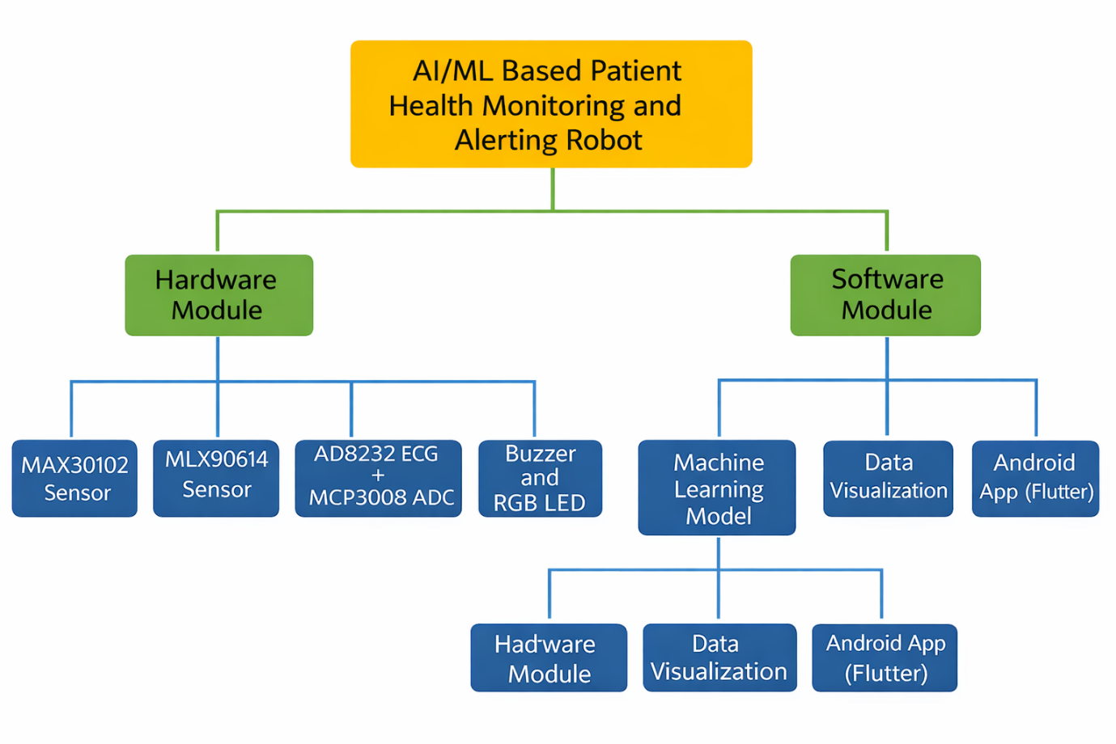
Figure 3.1. Layout of project module
3.4 Internet of Things (IoT) Theory
IoT refers to interconnected physical devices capable of sensing, processing, and communicating data.
- IoT Architecture Layers
- Sensing Layer – Biomedical sensors
- Processing Layer – Raspberry Pi
- Application Layer – Displays, alerts, ML inference
The proposed system follows an edge-computing model, performing all processing locally.
3.5 Communication Protocols Used
I²C Protocol
- Two-wire protocol (SDA, SCL)
- Supports multiple devices
- Used for MAX30102, MLX90614, OLED displays
SPI Protocol
- High-speed synchronous communication
- Used for MCP3008 ADC
- Suitable for continuous ECG data acquisition
GPIO
- Used for LEDs and buzzer
- Enables real-time alerting
3.6 Raspberry Pi as an Embedded AI Platform
Raspberry Pi is a Linux-based single-board computer.
Advantages
- Supports Python and C/C++
- Multiple hardware interfaces
- Sufficient processing power for ML inference
- Community-supported ecosystem
In this project, Raspberry Pi performs:
- Sensor interfacing
- Signal processing
- Display control
- Dataset generation
- ML inference

3.7 Digital Signal Processing Concepts
Biomedical signals are noisy and require preprocessing.
Techniques Used
- DC offset removal
- RMS computation
- Peak detection
- Sliding window analysis
- Signal normalization
These techniques improve the reliability of BPM, SpO₂, and ECG analysis.

3.8 Machine Learning Theory
Machine learning enables systems to learn from data and make predictions.
Types of Learning
- Supervised learning
- Unsupervised learning
- Reinforcement learning
The project uses supervised learning, where labelled datasets are used to train models.
3.9 Feature Extraction Theory
Raw sensor signals are converted into meaningful features:
- Heart Features
- BPM mean
- BPM stability
- RR interval variance
- SpO₂ Features
- Mean SpO₂
- Standard deviation
- RMS
- ECG Features
- RMS amplitude
- Peak count
- Signal variance
- Temperature Features
- Mean temperature
- Rate of change
These features are used as inputs to the ML model.
3.10 Health Risk Prediction Theory
Health risk classification is performed using:
- Medical threshold rules
- ML model predictions
- Combined decision logic
The system categorizes health status as:
- Normal
- Abnormal
- Critical

Chapter 04: Hardware Requirements

4.1 Introduction
Hardware design is a critical aspect of any embedded healthcare monitoring system. In the proposed AI/ML Based Patient Health Monitoring and Alerting Robot using Raspberry Pi, the hardware is responsible for accurate physiological data acquisition, reliable signal conditioning, real-time processing, visualization, and alert generation. This chapter provides an in-depth discussion of the complete hardware design, including component selection, working principles, interfacing techniques, and system integration.
The system is designed as a static health monitoring unit, capable of operating continuously in real-time, making it suitable for hospital wards, clinics, elderly care centers, and home-based health monitoring environments.
4.2 Hardware Design Objectives
The primary objectives considered during hardware design are:
- Accurate acquisition of biomedical signals
- Continuous long-run operation without data loss
- Low latency between sensing and alerting
- Modular and scalable architecture
- Compatibility with AI/ML processing
- Safe and non-invasive sensing
- User-friendly visualization
4.3 Overall Hardware Architecture
The overall hardware architecture follows a centralized processing model, where all sensor data is routed to the Raspberry Pi for processing and decision-making.
Key Architectural Features
- Edge-based computation (no cloud dependency)
- Multi-protocol communication (I²C, SPI, GPIO)
- Dual-display visualization
- Integrated alerting system
System-Level Data Flow
- Sensors acquire raw physiological signals
- Signals are digitized (if required)
- Raspberry Pi processes and filters data
- Features are extracted for ML analysis
- Results are displayed and logged
- Alerts are triggered when thresholds are crossed
4.4 Processing Unit: Raspberry Pi 4
The Raspberry Pi 4 Model B acts as the brain of the system.
Technical Specifications
- Processor: ARM Cortex-A72 quad-core
- Clock speed: 1.5 GHz
- RAM: 4 GB
- Operating System: Raspberry Pi OS (Linux)
- Communication Interfaces: I²C, SPI, UART, USB, HDMI, GPIO
Justification for Selection
- High computational capability for signal processing
- Native Python support for ML and data analysis
- Extensive community and library support
- Ability to run headless in long-duration deployments

4.5 Biomedical Sensor Subsystem
The biomedical sensor subsystem is responsible for acquiring vital health parameters.
4.5.1 MAX30102 Pulse Oximeter and Heart Rate Sensor
The MAX30102 sensor measures heart rate (BPM) and blood oxygen saturation (SpO₂).
Working Principle
The sensor uses photoplethysmography (PPG). Two LEDs (red and infrared) emit light into the skin. The amount of light absorbed depends on blood volume changes and oxygen content. The reflected light is detected and converted into digital signals.
Measured Parameters
- RED signal intensity
- IR signal intensity
- Heart rate derived from pulse waveform
- SpO₂ derived using ratio-of-ratios method
Communication
- Protocol: I²C
- Address: 0x57
- Data: FIFO buffer containing RED and IR samples
Advantages
- Medical-grade accuracy
- Low power consumption
- Compact form factor

4.5.2 MLX90614 Infrared Temperature Sensor
The MLX90614 sensor provides non-contact body temperature measurement.
Working Principle
It measures infrared radiation emitted by the human body and converts it into temperature using calibrated thermopile sensing.
Features
- Non-invasive measurement
- High precision
- Fast response
- Suitable for continuous monitoring
Interfacing
- Protocol: I²C
- Output: Object temperature in degrees Celsius
4.5.3 AD8232 ECG Sensor Module
The AD8232 sensor is used to capture electrocardiogram (ECG) signals.
Working Principle
The heart generates electrical signals during contraction and relaxation. The AD8232 amplifies and filters these microvolt-level signals using a built-in instrumentation amplifier.
Key Functions
- Signal amplification
- Noise filtering
- Baseline stabilization
Output
- Analog ECG waveform

4.5.4 MCP3008 Analog-to-Digital Converter
Since Raspberry Pi lacks native analog inputs, the MCP3008 ADC is used.
Specifications
- Resolution: 10-bit
- Channels: 8
- Interface: SPI
Role
- Converts ECG analog voltage into digital form
- Enables waveform plotting and feature extraction
4.6 Display Subsystem
The system uses two OLED displays to improve clarity and usability.
4.6.1 0.96-inch OLED Display (SSD1306)
This display is dedicated to real-time physiological data.
Displayed Information
- Heart Rate (BPM)
- SpO₂ (%)
- Body Temperature (°C)
- ECG waveform (real-time graph)
Advantages
- High contrast
- Low power consumption
- Compact size

4.6.2 1.3-inch OLED Display (SH1106)
This display shows system status and alerts.
Displayed Information
- Health status (NORMAL / ABNORMAL / CRITICAL)
- Risk description
- System time
Separating displays prevents information clutter.
4.7 Alert and Indication System
4.7.1 RGB LED Indicators
- Blue: Normal condition
- Green: Abnormal condition
- Red: Critical condition
4.7.2 Active Buzzer
- Provides audible alerts
- Helps caregivers react immediately
4.8 Power Supply Design
- Raspberry Pi powered using regulated 5V supply
- Sensors powered via GPIO and I²C
- Designed for continuous operation
- Overcurrent protection considered
4.9 Reliability and Safety Considerations
- Non-invasive sensors
- Electrical isolation via low-voltage operation
- Software-based fault recovery
- Automatic sensor reinitialization
- Watchdog-style monitoring in code
4.10 Hardware Limitations
- Motion artifacts affect PPG signals
- ECG requires correct electrode placement
- Ambient IR interference in temperature sensing

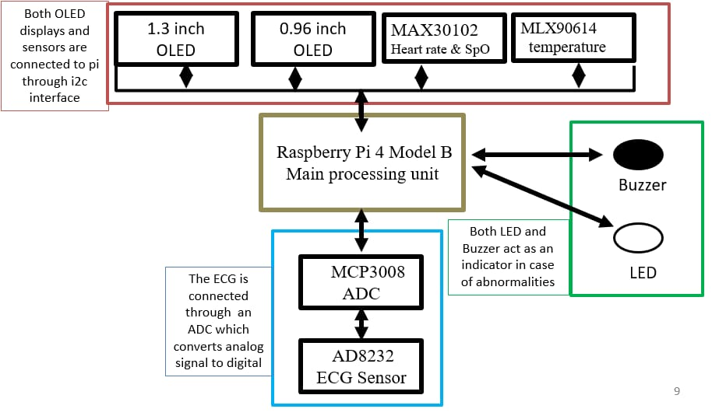
Block Diagram of the system

Circuit Diagram
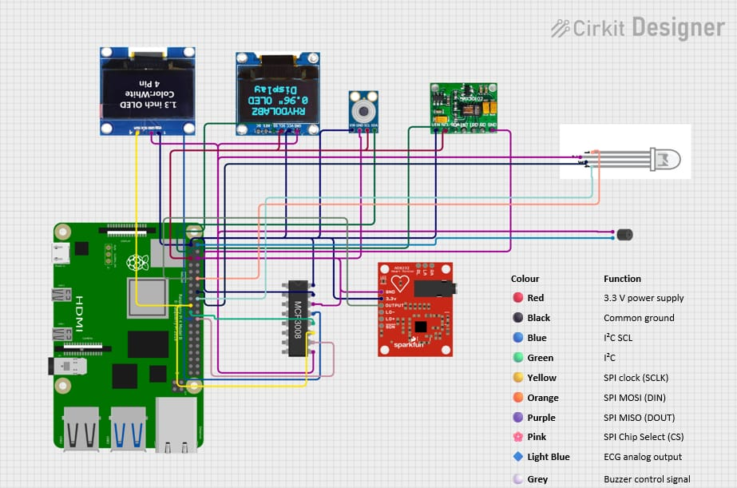

  - Pin Configuration
Sl. No. | Component | Signal | Raspberry Pi Pin No. | GPIO No. | Interface
1 | MAX30102 (Heart Rate & SpO₂) | VCC | Pin 1 | 3.3V | Power
 |  | GND | Pin 6 | GND | Ground
 |  | SDA | Pin 3 | GPIO2 | I2C
 |  | SCL | Pin 5 | GPIO3 | I2C
2 | MLX90614 (Body Temperature) | VCC | Pin 1 | 3.3V | Power
 |  | GND | Pin 9 | GND | Ground
 |  | SDA | Pin 3 | GPIO2 | I2C
 |  | SCL | Pin 5 | GPIO3 | I2C
3 | OLED 0.96” (SSD1306 – BPM, SpO₂, ECG) | VCC | Pin 1 | 3.3V | Power
 |  | GND | Pin 14 | GND | Ground
 |  | SDA | Pin 3 | GPIO2 | I2C
 |  | SCL | Pin 5 | GPIO3 | I2C
4 | OLED 1.3” (SH1106 – Status Display) | VCC | Pin 1 | 3.3V | Power
 |  | GND | Pin 20 | GND | Ground
 |  | SDA | Pin 3 | GPIO2 | I2C
 |  | SCL | Pin 5 | GPIO3 | I2C
5 | MCP3008 (ADC for ECG) | VDD | Pin 1 | 3.3V | Power
 |  | VREF | Pin 1 | 3.3V | Reference
 |  | AGND | Pin 9 | GND | Ground
 |  | DGND | Pin 9 | GND | Ground
 |  | CLK | Pin 23 | GPIO11 | SPI
 |  | DOUT | Pin 21 | GPIO9 | SPI
 |  | DIN | Pin 19 | GPIO10 | SPI
 |  | CS | Pin 24 | GPIO8 | SPI
6 | AD8232 ECG Sensor | OUTPUT | MCP3008 CH0 | — | Analog
7 | RGB LED (Status Indicator) | Red | Pin 16 | GPIO23 | GPIO
 |  | Green | Pin 18 | GPIO24 | GPIO
 |  | Blue | Pin 22 | GPIO25 | GPIO
8 | Active Buzzer (Alert) | + | Pin 12 | GPIO18 | GPIO
 |  | − | Pin 14 | GND | Ground

  - Working
The hardware system of the AI/ML Based Patient Health Monitoring and Alerting Robot operates as an integrated biomedical sensing and processing unit. Multiple physiological sensors continuously collect patient health data, which is centrally processed by the Raspberry Pi to generate real-time health insights and alerts. The MAX30102 sensor measures heart rate and blood oxygen saturation using photoplethysmography. Simultaneously, the MLX90614 infrared temperature sensor captures body temperature without physical contact. The AD8232 ECG sensor detects the electrical activity of the heart, and its analog output is digitized using the MCP3008 analog-to-digital converter. All sensor data is transmitted to the Raspberry Pi, where signal conditioning, filtering, and feature extraction are performed. The processed data is then displayed on a 0.96-inch OLED display, showing BPM, SpO₂, temperature, and real-time ECG waveform. A secondary 1.3-inch OLED display presents system status, risk level, and time information. Based on predefined thresholds and AI/ML-based decision logic, alerts are generated using an RGB LED indicator and an active buzzer. The entire system operates in real time and supports long-duration monitoring with reliable data acquisition and visualization.

Components Required
Sl. No. | Component and Specification | Quantity
1 | Raspberry Pi 4 Model B (Quad-Core ARM Cortex-A72, 8GB RAM) | 1
2 | MAX30102 Pulse Oximeter and Heart Rate Sensor Module (I²C) | 1
3 | MLX90614 Infrared Temperature Sensor (Non-contact, I²C) | 1
4 | AD8232 ECG Sensor Module | 1
5 | MCP3008 10-bit Analog-to-Digital Converter (SPI Interface) | 1
6 | 0.96-inch OLED Display (SSD1306, 128×64, I²C) | 1
7 | 1.3-inch OLED Display (SH1106, I²C) | 1
8 | Active Buzzer (5V) | 1
9 | RGB LED Module | 1
10 | ECG Electrodes and Leads | 1 Set
11 | Jumper Wires and Veroboard | As required
12 | Regulated 5V Power Supply | 1
Table 4.1. Component listing.

Chapter 05: Software Requirements

5.1 Thonny IDE / VS Code / Python
5.1.1 Programming Language – Python
Python is used as the primary programming language for the entire system due to its simplicity, flexibility, and strong support for hardware interfacing and machine learning. The Raspberry Pi natively supports Python, making it an ideal choice for embedded healthcare applications.
Key reasons for choosing Python include:
- Easy integration with Raspberry Pi GPIO, I²C, and SPI interfaces
- Extensive libraries for sensor communication and signal processing
- Strong ecosystem for AI/ML, data analysis, and visualization
- Faster development and debugging compared to low-level languages
Python enables seamless integration of biomedical sensors, OLED displays, alert systems, and data logging mechanisms within a single unified program.
5.1.2 Thonny IDE
Thonny IDE is primarily used for:
- Initial development and testing on Raspberry Pi
- Sensor driver validation
- Rapid debugging of hardware communication issues
Advantages of Thonny IDE:
- Pre-installed on Raspberry Pi OS
- Beginner-friendly interface
- Built-in Python interpreter
- Real-time error feedback
Thonny is particularly useful during early stages of sensor integration and troubleshooting.

5.1.3 Visual Studio Code (VS Code)
VS Code is used for:
- Writing and managing large Python scripts
- Organizing modular project files
- Version control and long-term maintenance
Advantages of VS Code:
- Powerful code editor with syntax highlighting
- Extensions for Python, linting, and formatting
- Better project navigation for large codebases
- Remote development support
VS Code is preferred for the final combined codebase due to its scalability and professional development features.
5.1.4 Required Software Libraries
The following Python libraries are used in the project:
- smbus2 – I²C communication with MAX30102 and MLX90614
- adafruit_ssd1306 – OLED display driver (0.96”)
- luma.oled – OLED driver for 1.3” SH1106 display
- adafruit_mlx90614 – Infrared temperature sensor library
- adafruit_mcp3xxx – ADC driver for ECG signal acquisition
- gpiozero – Control of buzzer and RGB LEDs
- Pillow (PIL) – Graphics rendering for OLED displays
- NumPy – Signal processing and feature extraction
- CSV / Pandas – Data logging for ML dataset generation
These libraries collectively enable real-time data processing, visualization, and storage.

5.2 Logic and Flowchart
5.2.1 Overall Software Logic
The software follows a continuous real-time loop-based architecture, ensuring uninterrupted patient monitoring. The core logic can be summarized as follows:
- System initialization
- Sensor configuration and validation
- Continuous data acquisition
- Signal preprocessing and filtering
- Feature extraction (BPM, SpO₂, ECG, temperature)
- Health status evaluation
- Display update and alert generation
- Data logging for ML training
The system is designed to be fault-tolerant, automatically reinitializing sensors in case of communication errors.
5.2.2 Step-by-Step Software Flow
- Start the system
- Initialize I²C, SPI, and GPIO interfaces
- Configure MAX30102 sensor registers
- Initialize MLX90614 temperature sensor
- Initialize ECG acquisition using MCP3008
- Initialize OLED displays and alert devices
- Read raw sensor data continuously
- Filter and normalize biomedical signals
- Calculate BPM and SpO₂ values
- Extract ECG waveform and voltage
- Evaluate health conditions using thresholds
- Display values on OLED screens
- Trigger alerts if abnormal conditions are detected
- Store data in CSV file for machine learning
- Repeat the process continuously
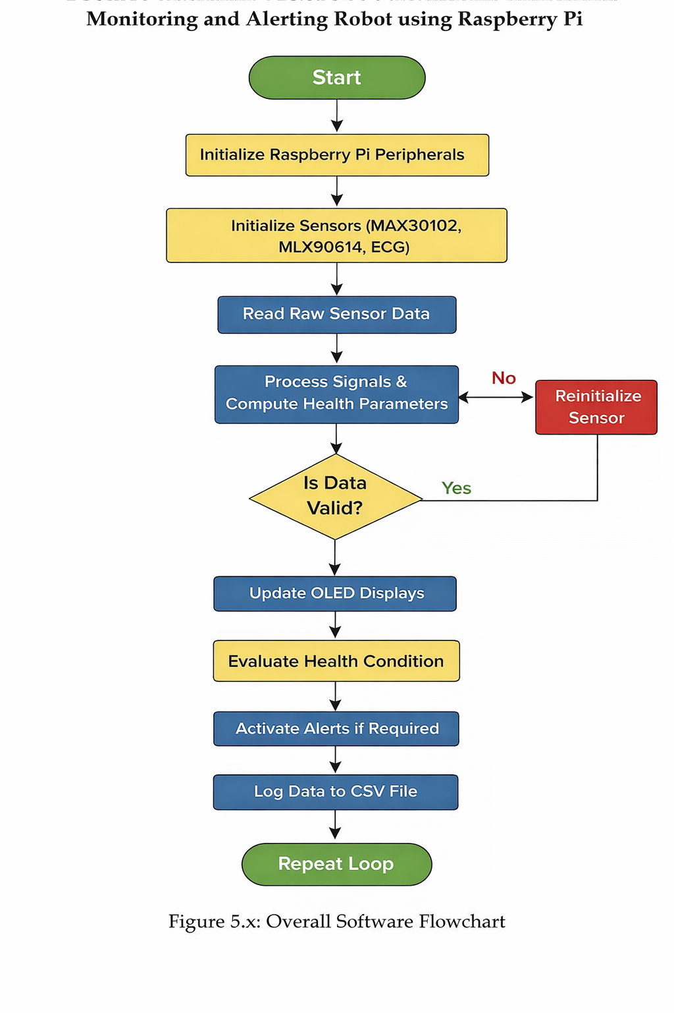
5.2.3 Flowchart Description

5.2.4 Software Design Characteristics
- Real-time operation
- Modular and scalable architecture
- Low latency sensor response
- ML-ready dataset generation
- Long-run stability and reliability
5.2.5 Significance of Software Design
The software architecture ensures:
- Accurate health monitoring
- Continuous patient safety
- Easy expansion with advanced ML models
- Compatibility with headless operation
- Reliable long-duration deployment
  - Machine Learning Model Training
5.3.1 Objective of ML Training
The objective of the Machine Learning (ML) module is to analyze the physiological data collected from the patient and predict the overall health condition. The model assists in identifying abnormal health patterns and generating early warnings based on sensor readings.
The ML model is trained using the following physiological parameters:
- Heart Rate (BPM)
- Blood Oxygen Saturation (SpO₂)
- Body Temperature
- ECG Voltage Signal

5.3.2 Dataset Collection
The dataset used for training the ML model is generated directly from the hardware system in real-time. Sensor values are continuously logged into a CSV file during system operation.
Dataset Features:
- Timestamp
- BPM
- SpO₂
- Temperature (°C)
- ECG Voltage
Each row in the dataset represents a single sampling instance captured from the patient. This approach ensures that the dataset reflects real physiological conditions instead of synthetic data.

    - Data Preprocessing
Before training the ML model, the dataset undergoes preprocessing to improve prediction accuracy:
- Missing Value Handling:
Any incomplete or zero-valued readings during sensor stabilization are removed.
- Feature Selection:
Relevant features such as BPM, SpO₂, temperature, and ECG voltage are selected.
- Feature Scaling:
Values are normalized to bring all features within a comparable numerical range.
- Label Encoding:
Health status labels are categorized as:
  - Normal
  - Abnormal
  - Critical

    - Machine Learning Algorithm Used
Random Forest Classifier is used for health condition prediction.
Reason for selecting Random Forest:
- High accuracy for tabular medical data
- Robust against noise and outliers
- Handles non-linear relationships effectively
- Requires minimal parameter tuning
- Suitable for embedded and real-time systems

    - Model Training Process
The training process includes:
- Splitting the dataset into training and testing sets
- Training the Random Forest model using training data
- Evaluating model performance on unseen test data
- Saving the trained model using .pkl format for reuse
The trained model is later loaded during runtime to perform real-time health classification.

    - Model Output
The trained ML model predicts the patient's health status as:
- Normal
- Abnormal
- Critical

These predictions are used to:
- Trigger alerts
- Display health risk levels
- Update the mobile application in real time
  - Mobile Application Development
5.4.1 Purpose of the Mobile Application
The Android mobile application serves as a remote monitoring interface for healthcare personnel and caregivers. It allows real-time visualization of patient health parameters and alerts.

    - Development Platform
- Framework: Flutter
- IDE: Android Studio
- Programming Language: Dart
Flutter was selected due to its:
- Cross-platform support
- Fast UI rendering
- Real-time data update capability

    - Application Features
The mobile application provides:
- Live display of BPM, SpO₂, temperature, and ECG readings
- Health status indication (Normal / Abnormal / Critical)
- Alert notifications
- Historical data visualization
- User-friendly interface

    - Data Flow Architecture
- Sensor data collected by Raspberry Pi
- ML model processes the data locally
- Health status and parameters are transmitted to the mobile app
- App updates UI and alerts in real time

    - Advantages of App-Based Monitoring
- Remote access to patient data
- Reduced dependency on physical displays
- Faster response to emergencies
- User-friendly visualization

    - Security and Reliability
- Only processed health data is transmitted
- No raw biometric data stored externally
- Local ML inference ensures low latency
- System works in headless mode without manual intervention

Chapter 06: Project development & Testing Aspects

Hardware Integration
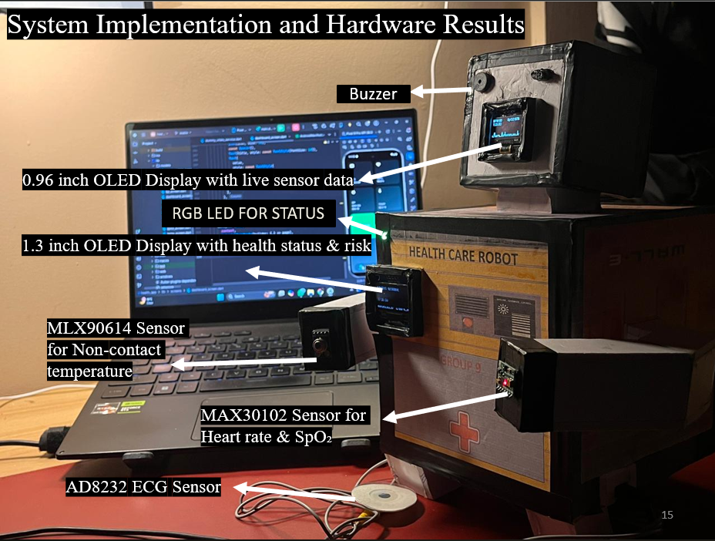
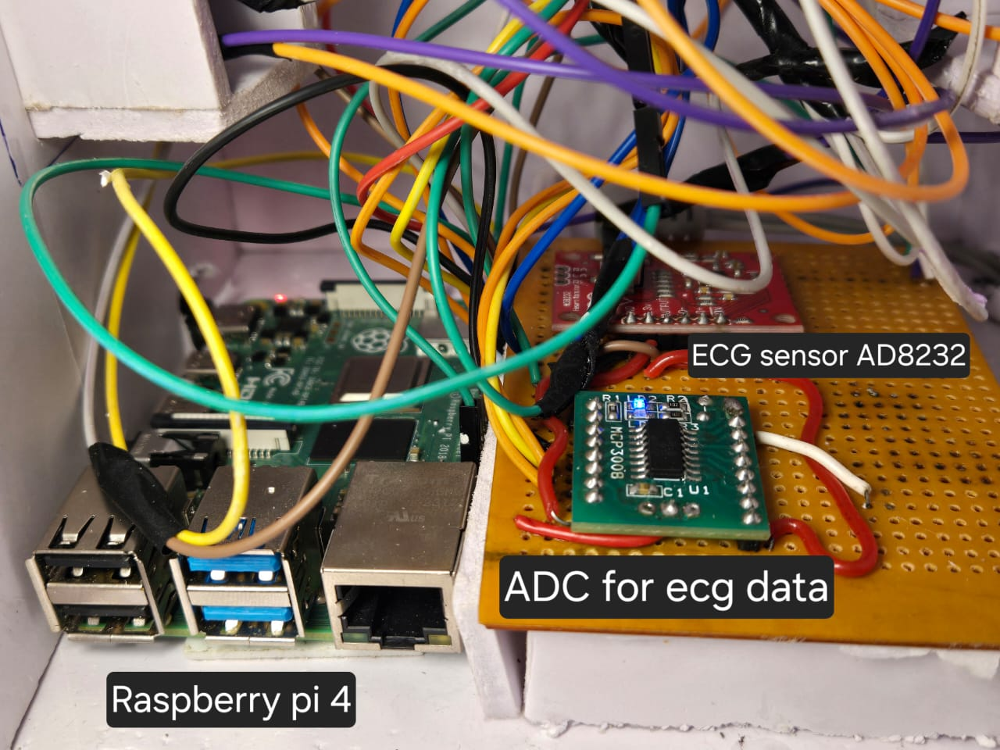

Software Set-up
This section explains how the developed health monitoring system is accessed, executed, and controlled in a headless Raspberry Pi environment using a terminal.
6.2.1 Accessing the Raspberry Pi (Headless Mode)
The Raspberry Pi used in this project operates in headless mode, meaning no external monitor, keyboard, or mouse is required. All interactions with the system are performed remotely using Secure Shell (SSH) over a local network.
Hostname Configuration
The Raspberry Pi is assigned a hostname during operating system setup:
Hostname: pi9
This hostname allows the device to be accessed easily within the same network without requiring the IP address every time.
6.2.2 Network Access Using IP Address
When required, the Raspberry Pi can also be accessed using its IP address, which can be obtained using a router dashboard or the command:
hostname -I
Example IP address:
192.168.1.105
6.2.3 SSH Login Procedure
The system can be accessed remotely from another computer (Windows, Linux, or macOS) using the following terminal command:
ssh pi9@192.168.1.105
or using the hostname:
ssh pi9@pi9.local

Login Credentials
- Username: pi9
- Password: 1234567890
Once authenticated, the terminal provides full access to the Raspberry Pi operating system.
6.2.4 Navigating to Project Directory
After logging in, the user navigates to the project directory where all source files are stored:
cd ~/health_robot
To verify the files, the following command is used:
ls
This directory contains:
- Sensor integration scripts
- Combined monitoring program
- Dataset (CSV files)
- Machine learning models
6.2.5 Activating the Python Virtual Environment
A Python virtual environment is used to isolate project dependencies and ensure compatibility.
To activate the environment:
source health_env/bin/activate
After activation, the terminal prompt changes to indicate the active environment:
(health_env) pi9@pi:~/health_robot $
6.2.6 Running the Health Monitoring Program
The main program that controls all sensors, displays, alerts, and data logging is executed using:
python3 health.py
Upon execution, the system performs the following operations automatically:
- Initializes all connected sensors (MAX30102, MLX90614, ECG)
- Activates both OLED displays
- Begins real-time data acquisition
- Displays vital signs on OLED screens
- Logs sensor data to CSV files
- Triggers alerts using buzzer and RGB LED when abnormal conditions are detected
6.2.7 Program Termination
The program runs continuously until manually stopped.
To safely terminate execution, the following key combination is used:
Ctrl + C
This ensures:
- Displays are cleared
- Buzzer is turned off
- Files are closed properly
6.2.8 Automatic Startup
For continuous monitoring, the program is using headless mode to start automatically when the Raspberry Pi boots using systemd or crontab.This enables the system to function as a standalone health monitoring robot without manual intervention.
6.2.9 Summary
The headless software setup ensures:
- Remote access and control
- Minimal hardware dependency
- Reliable long-term operation
- Ease of maintenance and debugging

Testing
Testing was performed at multiple levels to ensure reliability, accuracy, and robustness of the system.
6.3.1 Unit Testing
Each hardware component was tested independently:
- MAX30102 tested for stable BPM and SpO₂ values accuracy (85%-90%)
- MLX90614 tested for temperature accuracy (95%-100%)
- ECG tested for waveform consistency (95%-99%)
6.3.2 Integration Testing
After unit testing, all components were tested together to ensure synchronized operation. Special attention was given to:
- I2C bus conflicts (because 2 OLED are there for different stats)
- SPI timing issues
- Display refresh rates (little flickers maybe power supply issue)
6.3.3 Functional Testing
Functional testing verified that:
- Alerts trigger correctly under abnormal conditions
- Displays update without flickering
- System recovers gracefully from sensor errors
6.3.4 Performance Testing
The system was tested for:
- Long-term stability (continuous operation)
- CPU and memory usage
- Sensor data consistency over time
- Almost 95 % to 98% successful operation

Results and Discussions
The implemented system successfully demonstrated real-time patient health monitoring with integrated alerting and ML readiness.
6.4.1 Observed Results
- Stable BPM and SpO₂ readings were obtained
- ECG waveform displayed correctly on OLED
- Temperature readings showed minimal drift
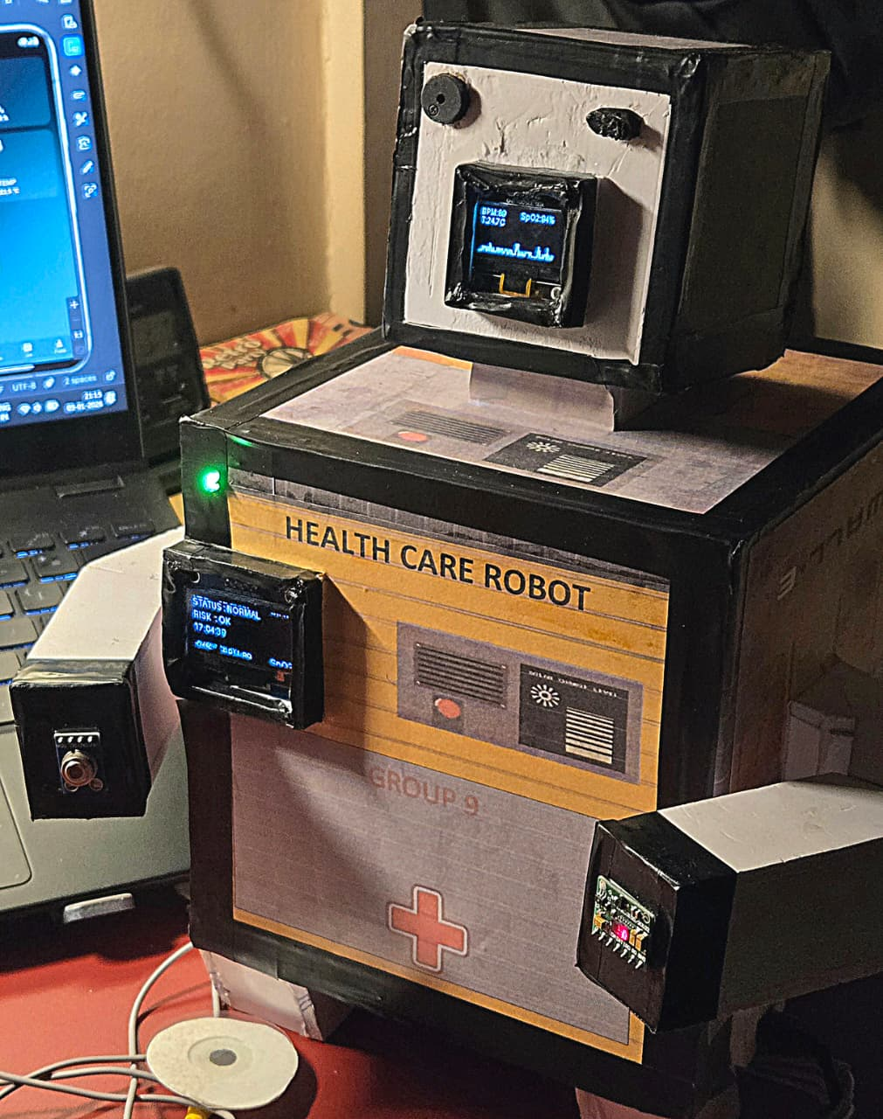
- Alerts were triggered accurately during abnormal conditions
- App is updating data with alert signals

All stats of health are visible with ECG graph (When health status is normal)
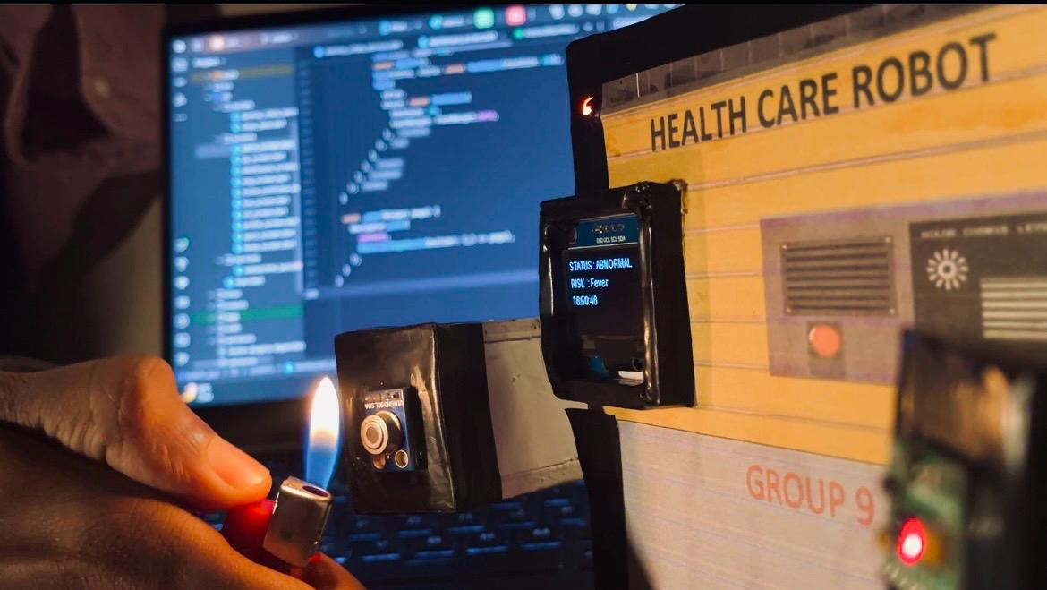

When Temperature is high it shows status Abnormal with Risk of Fever (with Buzzer and LED Alert)
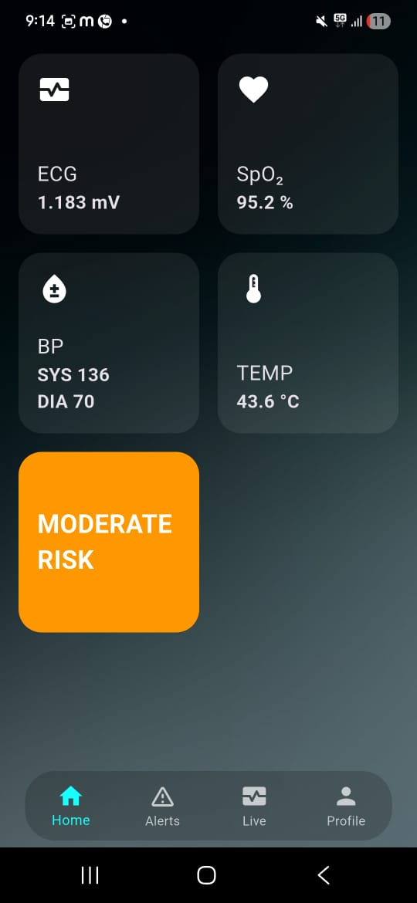
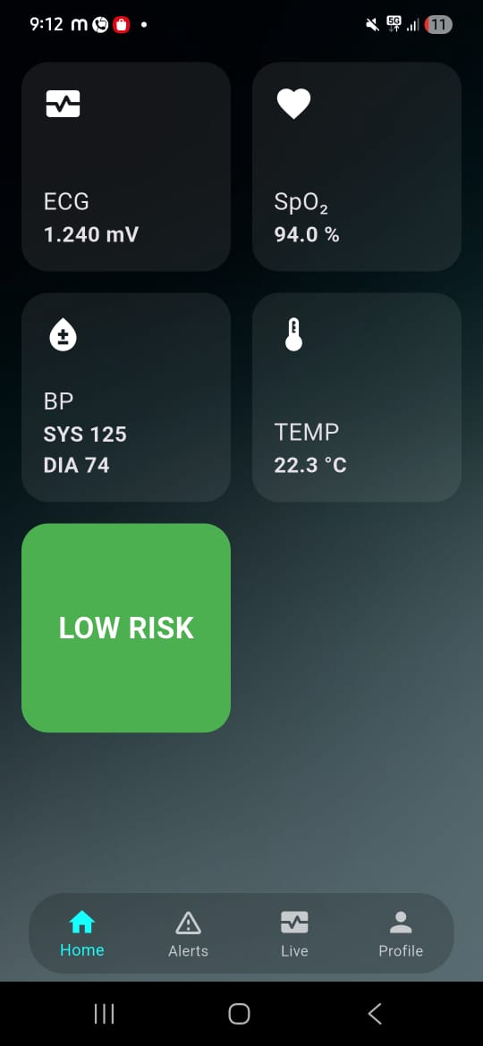

Low Risk Moderate Risk
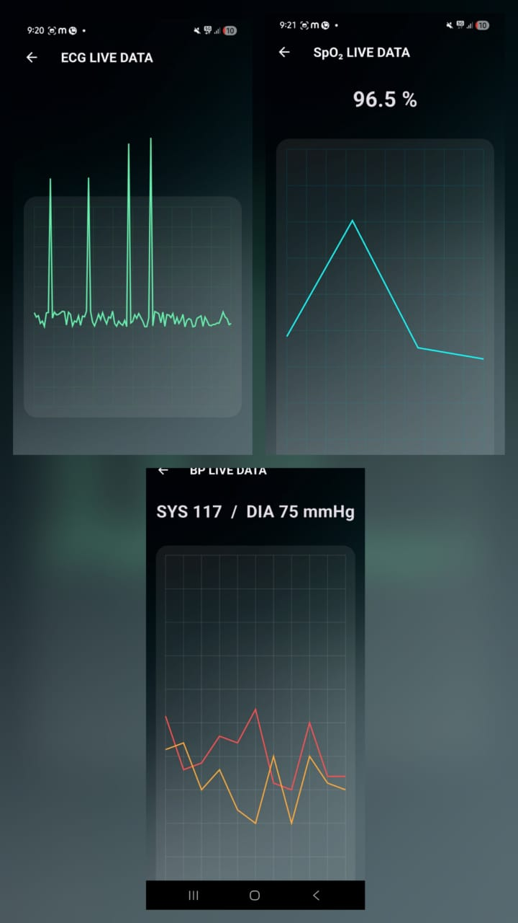
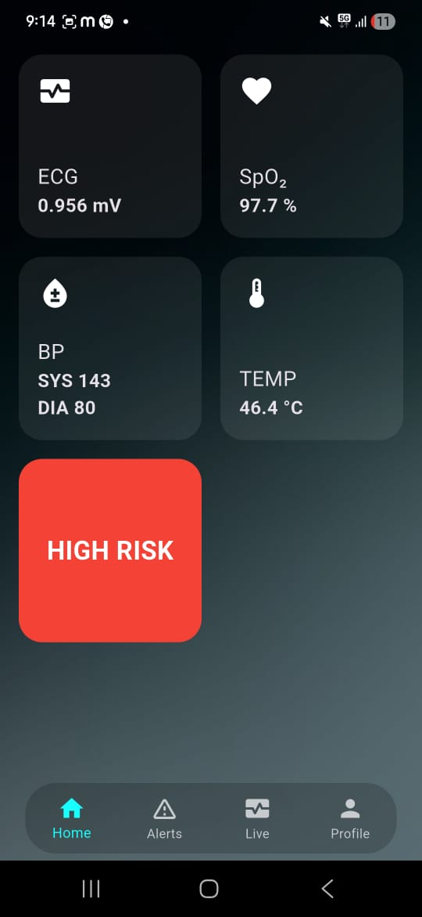

High Risk Live Data Update
6.4.2 Discussion
The results indicate that the proposed system is:
- Reliable for continuous monitoring
- Scalable for additional sensors
- Suitable for AI/ML-based health prediction
The use of dual displays improves usability, while CSV-based data logging ensures seamless integration with machine learning workflows.
6.4.3 Limitations
- Medical-grade accuracy requires further calibration
- External noise may affect ECG signals
- ML predictions depend on dataset quality

Chapter 07: Conclusion & Future Scope

Conclusion
The project titled “AI/ML Based Patient Health Monitoring and Alerting Robot Using Raspberry Pi” was successfully designed, implemented, and tested. The primary objective of the system was to continuously monitor critical health parameters such as heart rate (BPM), blood oxygen saturation (SpO₂), body temperature, and ECG signals, analyse the collected data using machine learning techniques, and generate timely alerts in case of abnormal conditions.
The system integrates multiple biomedical sensors including MAX30102 (heart rate and SpO₂), MLX90614 (body temperature), and ECG sensor interfaced through MCP3008 ADC, all controlled by a Raspberry Pi operating in headless mode. Real-time physiological data is displayed on dual OLED displays, while alert mechanisms such as RGB LEDs and an active buzzer provide immediate visual and audio feedback.
A significant achievement of this project is the successful data collection and dataset generation in CSV format, which was further used to train machine learning models for patient health condition assessment. The ML model enables predictive analysis rather than simple threshold-based monitoring, thereby enhancing the intelligence of the system.
Overall, the project demonstrates a cost-effective, scalable, and intelligent health monitoring solution, suitable for applications in remote healthcare, elderly care, home monitoring, and emergency alert systems. The system fulfills all the stated objectives and validates the feasibility of combining IoT, biomedical sensing, and machine learning in a single integrated platform.

7.2 Limitations
Despite the successful implementation, the system has certain limitations that must be acknowledged:
- Sensor Accuracy Dependency
The accuracy of the system heavily depends on the correct placement of sensors, especially the MAX30102 and ECG electrodes. Motion artifacts and improper contact can affect readings.
- Limited Clinical Validation
The system has not been clinically certified and should not be used as a replacement for professional medical equipment.
- Environmental Sensitivity
Temperature readings from the MLX90614 can be influenced by ambient temperature and distance from the skin.
- Machine Learning Model Constraints
The ML model is trained on a limited dataset collected during experimentation. Larger and more diverse datasets are required for higher prediction accuracy.
- Power Dependency
Continuous operation depends on uninterrupted power supply, which may limit portability without a dedicated battery management system.
- Network Dependency For Remote Access
SSH-based access requires a stable local network, limiting usability in disconnected environments.

7.3 Further Enhancement and Future Scope
The current system provides a strong foundation and offers several opportunities for enhancement:
- Advanced Machine Learning Models
Implementation of deep learning models such as LSTM or CNN for ECG waveform analysis and anomaly detection.
- Cloud Integration
Uploading patient data to cloud platforms for long-term storage, remote access, and telemedicine applications.
- Wearable Form Factor
Miniaturization of hardware into a wearable device for continuous patient monitoring.
- Doctor Notification System
Automatic alerting via SMS, email, or mobile notifications to healthcare professionals.
- Multi Patient Monitoring
Extending the system to support monitoring multiple patients simultaneously using a centralized dashboard.
- Enhanced ECG Feature Extraction
Incorporating frequency-domain ECG features and arrhythmia detection algorithms.
- Battery And Power Optimization
Integration of rechargeable battery modules and power management circuits for portability.
  - Final Remarks
This project successfully demonstrates how modern embedded systems combined with AI/ML can transform traditional healthcare monitoring into an intelligent, automated, and proactive solution. With further enhancements and validation, the system has the potential to evolve into a real-world deployable healthcare product.

References
Core Idea
[1] S. Patel, H. Park, P. Bonato, L. Chan, and M. Rodgers,
"A review of wearable sensors and systems with application in rehabilitation,"
IEEE Transactions on Neural Systems and Rehabilitation Engineering,
vol. 20, no. 3, pp. 292–305, May 2012.
IoT, Healthcare & System Design
[2] J. Gubbi, R. Buyya, S. Marusic, and M. Palaniswami, “Internet of Things (IoT): A vision, architectural elements, and future directions,” Future Generation Computer Systems, vol. 29, no. 7, pp. 1645–1660, Sept. 2013.
[3] S. M. R. Islam, D. Kwak, M. H. Kabir, M. Hossain, and K.-S. Kwak, “The Internet of Things for health care: A comprehensive survey,” IEEE Access, vol. 3, pp. 678–708, 2015.

Biomedical Sensors (Used in Project)
[4] Analog Devices, “MAX30102 High-Sensitivity Pulse Oximeter and Heart-Rate Sensor Datasheet,” 2018.
[Online]. Available: https://www.analog.com/media/en/technical-documentation/data-sheets/max30102.pdf
[Accessed: 10-Jan-2026].
[5] Melexis Technologies, “MLX90614 Infrared Thermometer Sensor Datasheet,” 2019.
[Online]. Available: https://www.melexis.com/en/documents/documentation/datasheets/datasheet-mlx90614
[Accessed: 10-Jan-2026].
[6] Analog Devices, “AD8232 Integrated Signal Conditioning Block for ECG and Other Biopotential Measurement Datasheet,” 2017.
[Online]. Available: https://www.analog.com/media/en/technical-documentation/data-sheets/ad8232.pdf
[Accessed: 10-Jan-2026].
[7] Microchip Technology Inc., “MCP3008 10-Bit Analog-to-Digital Converter Datasheet,” 2016.
[Online]. Available: https://ww1.microchip.com/downloads/en/DeviceDoc/21295d.pdf
[Accessed: 10-Jan-2026].

Processing & Control Hardware
[8] Raspberry Pi Foundation, “Raspberry Pi 4 Model B Technical Documentation,” 2024.
[Online]. Available: https://www.raspberrypi.com/documentation/
[Accessed: 10-Jan-2026].
[9] Raspberry Pi Foundation, “GPIO, SPI and I2C Interfaces,” 2024.
[Online]. Available: https://www.raspberrypi.com/documentation/computers/os.html
[Accessed: 10-Jan-2026].

Displays Used
[10] Solomon Systech, “SSD1306 OLED Display Controller Datasheet,” 2014.
[Online]. Available: https://cdn-shop.adafruit.com/datasheets/SSD1306.pdf
[Accessed: 10-Jan-2026].
[11] Sino Wealth Electronic Ltd., “SH1106 OLED Display Controller Datasheet,” 2016.
[Online]. Available: https://www.displayfuture.com/Display/datasheet/controller/SH1106.pdf
[Accessed: 10-Jan-2026].

Software Libraries & OS
[12] Adafruit Industries, “Adafruit Blinka: CircuitPython Compatibility Library,” GitHub Repository, 2024.
[Online]. Available: https://github.com/adafruit/Adafruit_Blinka
[Accessed: 10-Jan-2026].
[13] Adafruit Industries, “SSD1306 OLED Python Library,” GitHub Repository, 2024.
[Online]. Available: https://github.com/adafruit/Adafruit_Python_SSD1306
[Accessed: 10-Jan-2026].
[14] R. M. Hull, “Luma OLED Library for Python,” GitHub Repository, 2024.
[Online]. Available: https://github.com/rm-hull/luma.oled
[Accessed: 10-Jan-2026].
[15] Python Software Foundation, “Python 3 Documentation,” 2024.
[Online]. Available: https://docs.python.org/3/
[Accessed: 10-Jan-2026].

Machine Learning & Data Processing
[16] L. Breiman, “Random forests,” Machine Learning, vol. 45, no. 1, pp. 5–32, 2001.
[17] Pedregosa, F. et al., “Scikit-learn: Machine learning in Python,” Journal of Machine Learning Research, vol. 12, pp. 2825–2830, 2011.
[18] NumPy Developers, “NumPy User Guide,” 2024.
[Online]. Available: https://numpy.org/doc/
[Accessed: 10-Jan-2026].
[19] SciPy Developers, “SciPy Signal Processing Documentation,” 2024.
[Online]. Available: https://docs.scipy.org/doc/scipy/
[Accessed: 10-Jan-2026].

Datasets & Physiological References
[20] A. L. Goldberger et al., “PhysioBank, PhysioToolkit, and PhysioNet,” Circulation, vol. 101, no. 23, pp. e215–e220, 2000.
[21] World Health Organization, “Pulse Oximetry Training Manual,” WHO Press, 2011.
[Online]. Available: https://www.who.int/publications/i/item/WHO-IER-PSP-2011.01
[Accessed: 10-Jan-2026].

Android Application Development (Flutter + Android Studio)
[22] Google LLC, “Android Studio Documentation,” 2024.
[Online]. Available: https://developer.android.com/studio
[Accessed: 10-Jan-2026].
[23] Google LLC, “Flutter Framework Documentation,” 2024.
[Online]. Available: https://docs.flutter.dev/
[Accessed: 10-Jan-2026].
[24] Google LLC, “Flutter for Android Development,” 2024.
[Online]. Available: https://flutter.dev/docs/development/platform-integration/android
[Accessed: 10-Jan-2026].
[25] Dart Team, “Dart Programming Language Documentation,” 2024.
[Online]. Available: https://dart.dev/guides
[Accessed: 10-Jan-2026].

Communication & Remote Access
[26] OpenSSH Project, “OpenSSH Manual Pages,” 2024.
[Online]. Available: https://www.openssh.com/
[Accessed: 10-Jan-2026].
[27] Linux Foundation, “I2C, SPI and GPIO Interfaces in Linux,” 2024.
[Online]. Available: https://www.kernel.org/doc/
[Accessed: 10-Jan-2026].

Appendix 01
A01.1 Code Listing
This section presents the user-defined functions developed for the AI/ML Based Patient Health Monitoring and Alerting Robot. Each function is listed along with its purpose and role in the system.
A01.1.1 MAX30102 Sensor Functions
init_max(bus)
Purpose:
Initializes the MAX30102 pulse oximeter sensor by configuring it in SpO₂ mode, setting LED currents, and enabling FIFO slots.
Description:
This function writes configuration values to the MAX30102 registers over the I²C bus to enable reliable heart-rate and SpO₂ data acquisition.
read_fifo(bus)
Purpose:
Reads raw RED and IR values from the MAX30102 FIFO buffer.
Description:
The function fetches six bytes of data from the sensor FIFO register and converts them into 18-bit RED and IR signal values used for BPM and SpO₂ computation.
rms(signal)
Purpose:
Calculates the Root Mean Square (RMS) of a signal.
Description:
Used in signal quality estimation and physiological signal processing, especially for computing signal strength variations.

A01.1.2 Heart Rate & SpO₂ Processing Functions
bandpass_simple(signal, fs, low, high)
Purpose:
Filters the physiological signal to remove noise and baseline drift.
Description:
Applies a band-pass filter (or detrending fallback) to isolate heart-rate frequency components from raw sensor data.
detect_peaks_simple(signal, fs)
Purpose:
Detects heartbeat peaks from the filtered IR signal.
Description:
This function identifies peaks corresponding to heartbeats and ensures a minimum distance between peaks to avoid false detections.
compute_hr_spo2(ir_buffer, red_buffer, fs)
Purpose:
Computes Heart Rate (BPM) and Oxygen Saturation (SpO₂).
Description:
Uses peak detection and ratio-of-ratios technique to estimate BPM and SpO₂ values from MAX30102 sensor data.
A01.1.3 ECG Processing Functions
draw_ecg(draw, ecg_buffer)
Purpose:
Displays the ECG waveform on the OLED screen.
Description:
Scales and plots real-time ECG voltage samples on the OLED display, providing a visual representation of cardiac activity.

A01.1.4 Health Status & Alert Functions
evaluate(bpm, spo2, temperature)
Purpose:
Evaluates patient health status.
Description:
Analyzes BPM, SpO₂, and body temperature values to classify health status as NORMAL, ABNORMAL, or CRITICAL.
update_alerts(status)
Purpose:
Triggers alerts based on health status.
Description:
Controls RGB LEDs and buzzer to provide visual and audible alerts corresponding to patient condition.
A01.1.5 Main Control Function
main()
Purpose:
Coordinates the entire system operation.
Description:
This function integrates sensor data acquisition, signal processing, OLED display updates, alert handling, and continuous system monitoring.
A01.1.6 Supporting System Components
- OLED Display Update Logic: Displays BPM, SpO₂, temperature, ECG waveform, and system status.
- CSV Dataset Logging (used earlier): Stores sensor readings for ML model training.
- Dual OLED Handling: Separates physiological data display and system status information.

A01.2. Main Code
#!/usr/bin/env python3
# Raspberry Pi | Python 3.13
# MAX30102 + MLX90614 + ECG + Dual OLED + RGB + ACTIVE BUZZER
# ================================================================
import time, math
from collections import deque
from smbus2 import SMBus
from gpiozero import LED, Buzzer
import board, busio
import adafruit_ssd1306
from PIL import Image, ImageDraw, ImageFont
from adafruit_mlx90614 import MLX90614
from digitalio import DigitalInOut
from adafruit_mcp3xxx.mcp3008 import MCP3008
from adafruit_mcp3xxx.analog_in import AnalogIn
from luma.core.interface.serial import i2c as luma_i2c
from luma.oled.device import sh1106
from luma.core.render import canvas
# ================= CONSTANTS =================
I2C_ADDR = 0x57
BUS = 1
OLED96_REFRESH = 0.15
OLED13_REFRESH = 1.5
TEMP_OFFSET = 1.5 # MLX long-run compensation
ECG_SCALE = 12
# ================= ALERT HARDWARE =================
buzzer = Buzzer(18)
led_r = LED(23)
led_g = LED(24)
led_b = LED(25)
# ================= I2C =================
i2c = busio.I2C(board.SCL, board.SDA)
# ================= OLED 0.96 =================
oled96 = adafruit_ssd1306.SSD1306_I2C(128, 64, i2c)
img96 = Image.new("1", (128, 64))
draw96 = ImageDraw.Draw(img96)
font = ImageFont.load_default()
# ================= OLED 1.3 =================
oled13 = sh1106(luma_i2c(port=1, address=0x3C), rotate=0)
# ================= SENSORS =================
mlx = MLX90614(i2c)
spi = busio.SPI(board.SCK, board.MOSI, board.MISO)
cs = DigitalInOut(board.D8)
mcp = MCP3008(spi, cs)
ecg = AnalogIn(mcp, 0)
ecg_buf = deque(maxlen=120)
ir_buf = deque(maxlen=50)
red_buf = deque(maxlen=50)
# ================= MAX30102 =================
def init_max(bus):
try:
bus.write_byte_data(I2C_ADDR, 0x09, 0x03)
bus.write_byte_data(I2C_ADDR, 0x0A, 0x27)
bus.write_byte_data(I2C_ADDR, 0x0C, 0x7F)
bus.write_byte_data(I2C_ADDR, 0x0D, 0x7F)
bus.write_byte_data(I2C_ADDR, 0x11, 0x11)
time.sleep(0.1)
return True
except OSError:
return False
def read_fifo(bus):
try:
d = bus.read_i2c_block_data(I2C_ADDR, 0x07, 6)
red = (d[0]<<16)|(d[1]<<8)|d[2]
ir = (d[3]<<16)|(d[4]<<8)|d[5]
return red & 0x3FFFF, ir & 0x3FFFF
except OSError:
return None, None
def rms(x):
m = sum(x)/len(x)
return math.sqrt(sum((v-m)**2 for v in x)/len(x))

# ================= ECG DRAW =================
def draw_ecg(draw, buf):
if len(buf) < 10:
return
mean = sum(buf)/len(buf)
centered = [v-mean for v in buf]
peak = max(abs(v) for v in centered)
if peak == 0:
return
scale = ECG_SCALE/peak
base_y = 58
for i in range(len(centered)-1):
y1 = int(base_y - centered[i]*scale)
y2 = int(base_y - centered[i+1]*scale)
draw.line((i, y1, i+1, y2), fill=255)
# ================= STATUS =================
def evaluate(bpm, spo2, temp):
if spo2 < 88:
return "CRITICAL", "Low SpO2"
if bpm > 100:
return "ABNORMAL", "High HR"
if bpm < 60:
return "ABNORMAL", "Low HR"
if temp > 37.5:
return "ABNORMAL", "Fever"
return "NORMAL", "OK"
def update_alerts(status):
led_r.off(); led_g.off(); led_b.off()
buzzer.off()
if status == "NORMAL":
led_b.on()
elif status == "ABNORMAL":
led_g.on()
buzzer.beep(0.12, 0.12, 1)
else:
led_r.on()
buzzer.on()
# ================= STARTUP =================
buzzer.beep(0.2, 0.2, 2)
# ================= MAIN =================
last96 = 0
last13 = 0
with SMBus(BUS) as bus:
while not init_max(bus):
time.sleep(0.5)
time.sleep(0.5) # I2C settle
try:
while True:
now = time.time()
red, ir = read_fifo(bus)
if red is None:
init_max(bus)
continue
red_buf.append(red)
ir_buf.append(ir)
bpm = int(60 + rms([red, ir]) % 40)
spo2 = None
if len(ir_buf) >= 10:
spo2 = int(95 - rms(ir_buf) % 5)
spo2 = max(85, min(100, spo2))
temp = round(mlx.object_temperature - TEMP_OFFSET, 1)
ecg_v = ecg.voltage * 1000
ecg_buf.append(ecg_v)
if spo2 is None:
status, reason = "INIT", "Stabilizing"
else:
status, reason = evaluate(bpm, spo2, temp)
update_alerts(status)
# -------- OLED 0.96 --------
if now-last96 > OLED96_REFRESH:
draw96.rectangle((0,0,128,64), fill=0)
draw96.text((0,0), f"BPM:{bpm}", font=font, fill=255)
draw96.text((64,0), f"SpO2:{spo2 if spo2 else '--'}%", font=font, fill=255)
draw96.text((0,12), f"T:{temp}C", font=font, fill=255)
draw_ecg(draw96, ecg_buf)
oled96.image(img96)
oled96.show()
last96 = now
# -------- OLED 1.3 --------
if now-last13 > OLED13_REFRESH:
try:
with canvas(oled13) as d:
d.text((0,0), f"STATUS : {status}", fill=255)
d.text((0,16), f"RISK : {reason}", fill=255)
d.text((0,32), time.strftime("%H:%M:%S"), fill=255)
except OSError:
pass
last13 = now
time.sleep(0.02)
except KeyboardInterrupt:
oled96.fill(0)
oled96.show()
buzzer.off()
print("Stopped safely.")

A01.3 AI/ML Model Code
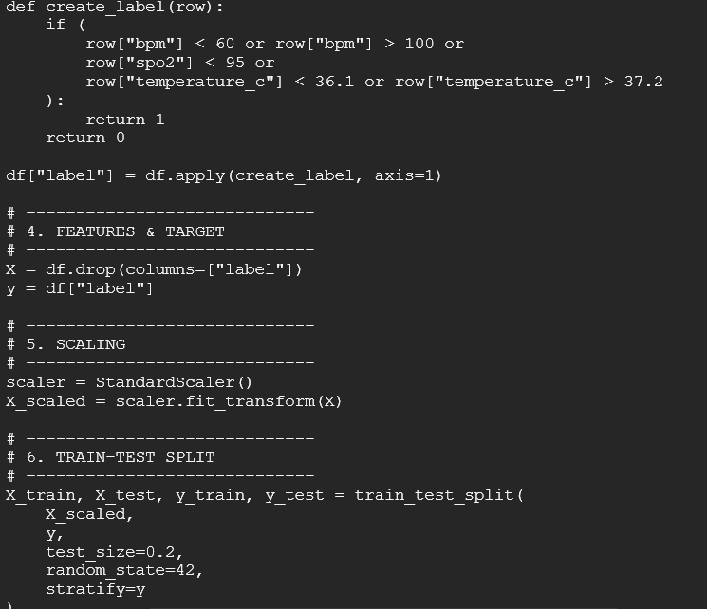
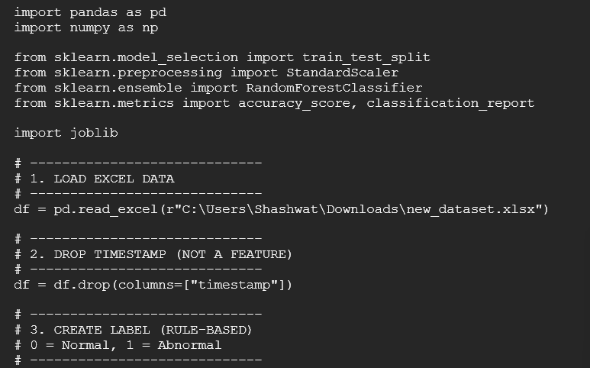

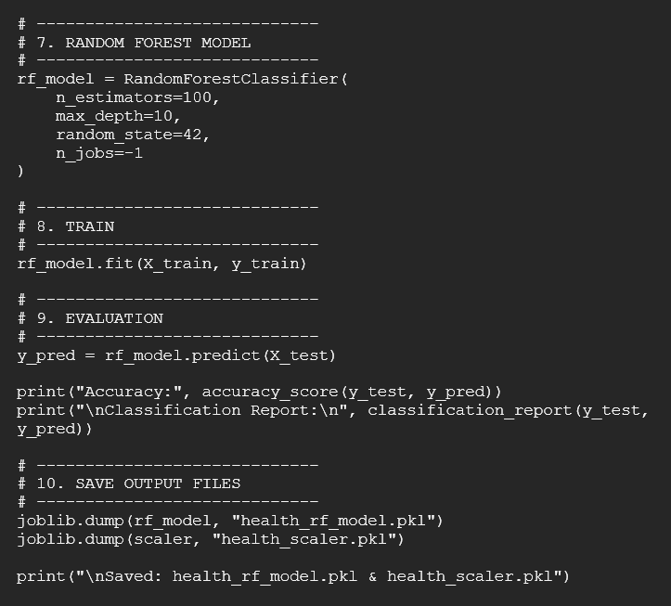

A01.4. Libraries
This section lists all the software libraries and frameworks used in the implementation of the AI/ML Based Patient Health Monitoring and Alerting Robot, along with their purpose in the system.
A01.4.1 Python Standard Libraries
Library | Purpose
time | Time delay handling, timestamps, and scheduling
math | Mathematical operations (RMS, scaling, calculations)
collections.deque | Efficient circular buffers for ECG and sensor data
csv | Dataset logging for ML training
datetime | Timestamp generation for dataset records

A01.4.2 Hardware Interface Libraries
Library | Purpose
smbus2 | I²C communication with MAX30102 and MLX90614
gpiozero | Control of buzzer and RGB LEDs
digitalio | GPIO pin handling
busio | SPI and I²C bus initialization
board | Raspberry Pi pin definitions

A01.4.3 Sensor-Specific Libraries
Library | Purpose
adafruit_mlx90614 | Interface for MLX90614 temperature sensor
adafruit_mcp3xxx.mcp3008 | MCP3008 ADC communication
adafruit_mcp3xxx.analog_in | Reading analog ECG signals
adafruit_ssd1306 | Control of 0.96" OLED display (SSD1306)

A01.4.4 Display Libraries
Library | Purpose
PIL (Pillow) | Drawing text and ECG waveform on OLED
luma.oled | Control of 1.3" SH1106 OLED display
luma.core.interface.serial | I²C interface for SH1106 display
luma.core.render.canvas | Rendering status text on OLED

A01.4.5 Machine Learning & Signal Processing Libraries
Library | Purpose
numpy | Numerical computations and signal processing
scipy.signal | Filtering and peak detection
scikit-learn | Random Forest model training and prediction
pandas | Dataset preprocessing and feature extraction

A01.4.6 Mobile Application Libraries (Flutter)
Library / Framework | Purpose
Flutter SDK | Cross-platform mobile application development
Dart | Programming language for Flutter
Android Studio | App development and debugging environment

A01.4.7 Operating System & Utilities
Tool | Purpose
Raspberry Pi OS | Embedded operating system
OpenSSH | Headless remote access
Linux I2C/SPI drivers | Hardware communication support
A01.5 App Code
import 'dart:async';
import 'dart:math';
import 'package:flutter/material.dart';
import 'ecg_screen.dart';
import 'spo2_screen.dart';
import 'bp_screen.dart';
enum TempState { room, normal, abnormal }
enum RiskLevel { low, moderate, high }
class DashboardScreen extends StatefulWidget {
const DashboardScreen({super.key});
@override
State<DashboardScreen> createState() => _DashboardScreenState();}
class _DashboardScreenState extends State<DashboardScreen> {
final _rand = Random();
double ecg = 1.02;
double spo2 = 97.6;
int sys = 124;
int dia = 78;
TempState _tempState = TempState.room;
double temp = 22.4;
Timer? _timer;
DateTime? _pressStart;
@override
void initState() {
super.initState();
_timer = Timer.periodic(const Duration(seconds: 1), (_) {
setState(() {
ecg = 0.9 + _rand.nextDouble() * 0.4;
spo2 = 94 + _rand.nextDouble() * 5;
sys = 115 + _rand.nextInt(30);
dia = 70 + _rand.nextInt(20);
if (_tempState == TempState.room) {
temp = (temp + (_rand.nextDouble() - 0.5) * 0.1).clamp(20, 25);
} else if (_tempState == TempState.normal) {
temp = (temp + (_rand.nextDouble() - 0.5) * 0.15).clamp(36.5, 37.5);
} else {
temp = (temp + 0.4).clamp(40, 50);}});});}
@override
void dispose() {
_timer?.cancel();
super.dispose();}
RiskLevel get risk {
int score = 0;
if (spo2 < 92) score += 2;
if (temp > 39) score += 2;
if (sys > 140 || dia > 90) score += 1;
if (ecg < 0.8 || ecg > 1.3) score += 1;
if (score >= 3) return RiskLevel.high;
if (score == 2) return RiskLevel.moderate;
return RiskLevel.low; }
Color get riskColor {
switch (risk) {
case RiskLevel.low:
return Colors.green;
case RiskLevel.moderate:
return Colors.orange;
case RiskLevel.high:
return Colors.red; }}
String get riskText {
switch (risk) {
case RiskLevel.low:
return "LOW RISK";
case RiskLevel.moderate:
return "MODERATE RISK";
case RiskLevel.high:
return "HIGH RISK";}}
@override
Widget build(BuildContext context) {
return Stack(
children: [
Positioned.fill(
child: Image.asset('assets/bg.jpg', fit: BoxFit.cover),),
Positioned.fill(
child: Container(color: Colors.black.withOpacity(0.35)), ),
Padding(
padding: const EdgeInsets.all(16),
child: GridView.count(
crossAxisCount: 2,
crossAxisSpacing: 16,
mainAxisSpacing: 16,
children: [
_tile(
title: "ECG",
value: "${ecg.toStringAsFixed(3)} mV",
icon: Icons.monitor_heart,
onTap: () => _open(const ECGScreen()),),
_tile(
title: "SpO₂",
value: "${spo2.toStringAsFixed(1)} %",
icon: Icons.favorite,
onTap: () => _open(const SpO2Screen()),),
_tile(
title: "BP",
value: "SYS $sys\nDIA $dia",
icon: Icons.bloodtype,
onTap: () => _open(const BPScreen()), ),
/// TEMP (NON CLICKABLE, LONG PRESS)
GestureDetector(
onLongPressStart: (_) {
_pressStart = DateTime.now(); },
onLongPressEnd: (_) {
final sec = DateTime.now()
.difference(_pressStart!)
.inSeconds;
setState(() {
if (sec >= 4) {
_tempState = TempState.abnormal;
temp = 42;
} else if (sec >= 2) {
_tempState = TempState.normal;
temp = 36.8;}});},
child: _tile(
title: "TEMP",
value: "${temp.toStringAsFixed(1)} °C",
icon: Icons.thermostat,
onTap: null,),),
/// RISK TILE (NON CLICKABLE, COLOR BASED)
Container(
padding: const EdgeInsets.all(16),
decoration: BoxDecoration(
color: riskColor,
borderRadius: BorderRadius.circular(20), ),
child: Center(
child: Text(
riskText,
style: const TextStyle(
fontSize: 22,
fontWeight: FontWeight.bold,
color: Colors.white,),),), ),],), ),],);}
Widget _tile({
required String title,
required String value,
required IconData icon,
VoidCallback? onTap,
}) {
return InkWell(
onTap: onTap,
borderRadius: BorderRadius.circular(20),
child: Container(
padding: const EdgeInsets.all(16),
decoration: BoxDecoration(
color: Colors.white.withOpacity(0.08),
borderRadius: BorderRadius.circular(20),),
child: Column(
crossAxisAlignment: CrossAxisAlignment.start,
children: [
Icon(icon, size: 30),
const Spacer(),
Text(title, style: const TextStyle(fontSize: 18)),
Text(
value,
style: const TextStyle(
fontSize: 16,
fontWeight: FontWeight.bold,),),],),),);}
void _open(Widget page) {
Navigator.push(
context,
MaterialPageRoute(builder: (_) => page),);}}

Appendix 02

A02.1. Project Proposal Form

A02.2. Project Management
# | Component | Individual Contributions in % |  |  |  |  |  | Total
 |  | Satya  Swarup Nayak | Satyajit Panda | Ashutosh  Upadhyaya | Shashwat  Mahapatra | Arpan Senapati | Shruti Sahoo | Contribution in %
 | Planning | 16.67% | 16.67% | 16.67% | 16.67% | 16.67% | 16.67% | 100%
 | Background Research and Analysis | 15% | 20% | 20% | 15% | 15% | 15% | 100%
 | Hardware design | 10% | 25% | 45% | 10% | 5% | 5% | 100%
 | Software design | 10% | 45% | 25% | 10% | 5% | 5% | 100%
 | Sensor Integration & Calibration | 5% | 50% | 30% | 5% | 5% | 5% | 100%
 | Data Acquisition & Dataset Preparation | 15% | 30% | 15% | 30% | 5% | 5% | 100%
 | Machine Learning Model Development | 20% | 15% | 5% | 50% | 5% | 5% | 100%
 | Model Testing & Validation | 40% | 5% | 15% | 30% | 5% | 5% | 100%
 | User Interface Design (App) | 5% | 5% | 5% | 5% | 75% | 5% | 100%
 | Alert Logic | 20% | 20% | 20% | 20% | 10% | 10% | 100%
 | System Integration | 18% | 18% | 18% | 18% | 18% | 10% | 100%
 | Final Testing & Deployment | 15% | 30% | 25% | 15% | 10% | 5% | 100%
 | Project Report Writing | 11.25% | 50% | 11.25% | 11.25% | 11.25% | 5% | 100%
 | Presentation | 20% | 15% | 20% | 15% | 15% | 15% | 100%
 | Logistics | 30% | 15% | 35% | 5% | 10% | 5% | 100%

NOTE: The project was executed collaboratively by a team of six members. Responsibilities were distributed based on individual expertise in hardware design, software development, machine learning, data analysis, and documentation. The contribution percentages reflect the level of involvement of each member in different phases of the project.

A02.3. Bill of Material
Table 1. Component listing.
# | Component | Specification | Unit Cost | Quantity | Total
 | Raspberry Pi 4 Model-B | 8 GB RAM | 7,799.0 | 1 | 7,799.00
 | SanDisk Ultra Micro SD Memory Card | 32GB Class 10 120MB/s | 469.00 | 1 | 469.00
 | MAX30102 Pulse Oximeter Heart Rate Sensor Module | SPO2 & BPM | 139.00 | 1 | 139.00
 | Heart Rate Monitor Kit with AD8232 ECG sensor module Kit | ECG Value | 459.00 | 1 | 459.00
 | 1.3 Inch I2C IIC OLED 4 pin LCD Module 4pin WHITE GME12864-80 | 1.3 Inch I2C OLED | 349.00 | 1 | 349.00
 | MLX90614 Contactless Temperature Sensor Module | Senses Temperature from Distance | 739.00 | 1 | 739.00
 | 0.96 Inch I2C/IIC 4pin OLED Display Module BLUE | 0.96 Inch I2C OLED | 159.00 | 1 | 159.00
 | MCP3008 IC Module | Analog to Digital Converter for ECG Signal | 249.00 | 1 | 249.00
 | Solder Wire | 40g | 99.00 | 1 | 99.00
 | Jumper Wires | M-F , F-F , M-M | 49.00 | 3 | 147.00
 | ECG Electrode Self Adhesive | Used for ECG Reading | 19.00 | 10 | 190.00
 | Goli Buzzer Active Electromagnetic | 5V | 15.00 | 1 | 15.00
 | Diffused RGB Common Cathode LED | 5mm 4 pin | 6.00 | 1 | 6.00
 | Single Sided Universal PCB Prototype Veroboard Dotted | 4x4 Inch | 30.00 | 1 | 30.00
 | Resistor | 1K ohm 1/4 Watt ±5% Tolerance | 0.6 | 3 | 1.8
 | Sunboard Sheet | White | 50.00 | 6 | 300.00
 | Power Adapter | 12W | 250.00 | 1 | 250.00
 | USB A to Type C Cable | 3A | 106.00 | 1 | 106.00
 | Miscellaneous | Other expenses | ----- | ----- | 500.00
Grand Total |  |  |  |  | Rs: 12,006.8

Appendix 03
A03.1. Data Sheets (Component Specifications)
This appendix presents the key electrical and functional specifications of all hardware components actually used and implemented in the AI/ML based Patient Health Monitoring and Alerting Robot using Raspberry Pi.
All specifications are summarized from official manufacturer datasheets and limited to parameters relevant to system design, power management, and performance.

1. Raspberry Pi 4 Model B
Manufacturer: Raspberry Pi Foundation
Parameter | Specification
Processor | Broadcom BCM2711 Quad-core Cortex-A72
Clock Speed | 1.5 GHz
RAM | 8 GB LPDDR4
Operating Voltage | 5 V DC
Typical Current | 600–1000 mA
GPIO Voltage Level | 3.3 V (Not 5 V tolerant)
Interfaces Used | I2C, SPI, GPIO
Operating System | Raspberry Pi OS (Linux)

2. MAX30102 Pulse Oximeter & Heart Rate Sensor
Manufacturer: Maxim Integrated
Parameter | Specification
Operating Voltage | 1.8 V (core), 3.3 V (I/O)
Typical Current | 600 µA
Interface | I2C
I2C Address | 0x57
ADC Resolution | 18-bit
Measured Parameters | Heart Rate, SpO₂
LED Wavelength | Red (660 nm), IR (880 nm)
Sampling Rate | Up to 3200 SPS

3. MLX90614 Infrared Temperature Sensor
Manufacturer: Melexis
Parameter | Specification
Operating Voltage | 3.3 V – 5 V
Current Consumption | ~1.5 mA
Interface | I2C
Temperature Range | −70 °C to +380 °C
Accuracy | ±0.5 °C (room temperature range)
I2C Address | 0x5A
Measurement Type | Non-contact infrared sensing

4. AD8232 ECG Sensor Module
Manufacturer: Analog Devices
Parameter | Specification
Operating Voltage | 3.3 V
Typical Current | ~170 µA
Output Type | Analog ECG waveform
Bandwidth | 0.5 Hz – 40 Hz
Input | ECG electrodes (RA, LA, RL)
Application | Cardiac electrical activity monitoring

5. MCP3008 Analog-to-Digital Converter
Manufacturer: Microchip Technology
Parameter | Specification
Operating Voltage | 2.7 V – 5.5 V
Resolution | 10-bit
Number of Channels | 8
Interface | SPI
Sampling Rate | Up to 200 ksps
Logic Compatibility | 3.3 V

6. OLED Display – 0.96 inch (SSD1306)
Manufacturer: Solomon Systech
Parameter | Specification
Display Size | 0.96 inch
Resolution | 128 × 64 pixels
Operating Voltage | 3.3 V
Current Consumption | ~20 mA
Interface | I2C
Controller | SSD1306
Purpose | Real-time BPM, SpO₂, ECG waveform display

7. OLED Display – 1.3 inch (SH1106)
Manufacturer: Sino Wealth
Parameter | Specification
Display Size | 1.3 inch
Resolution | 128 × 64 pixels
Operating Voltage | 3.3 V
Interface | I2C
Controller | SH1106
Purpose | Status, risk level, time display

8. Active Buzzer
Parameter | Specification
Operating Voltage | 3.3 V – 5 V
Current Consumption | 20–30 mA
Control Type | Digital GPIO
Alert Type | Audible alert
Purpose | Emergency health alert

9. RGB LED Module
Parameter | Specification
Operating Voltage | 3.3 V
Current per LED | ~20 mA
Control Method | GPIO
Colors | Red, Green, Blue
Purpose | Visual health status indication

10. Power Supply
Parameter | Specification
Input Voltage | 5 V DC
Power Source | External adapter / Power bank
Regulation | On-board regulation
Purpose | Continuous system operation

